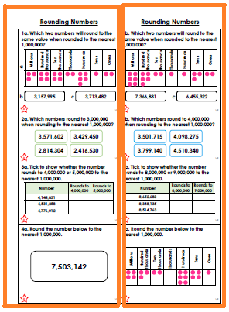
The coloured star to indicate differentiation.
The star will either be red (Developing), blue (Expected) or orange (Greater Depth).

- The red boxes show the questions the children should attempt.
- Children choose to answer the tasks in either the left hand box or the right hand box – not both.

- For this sheet, children will answer questions 1a, 2a, 3a and 4a or 1b, 2b, 3b or 4b.

