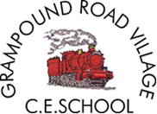

Our topic is

Do you want to

Be friends?

Staff:

Mrs Wilton (Class Teacher)

Miss Kennedy (Class Teacher)

Miss Warne and Mrs Theobald (Teaching Assistants)

Homework and Reading:

Homework to be handed out daily, it will be the phonic sound of the day. This will give the children an opportunity to practice writing the sounds they have learnt in school. Please also ensure that your child is reading daily. Reading books will be changed twice a week on a Monday and a Friday. Re-read each book more than once, this will enable your child to familiarise themselves with the story and to confidently re-tell the story to you. The reading books will not have words in at this stage. You can help by talking about the characters and setting and encouraging your child to respond to questions and make a narrative to describe the pictures.

**T**hank you for your on going support. I hope you feel your child is settled, happy and making good progress.

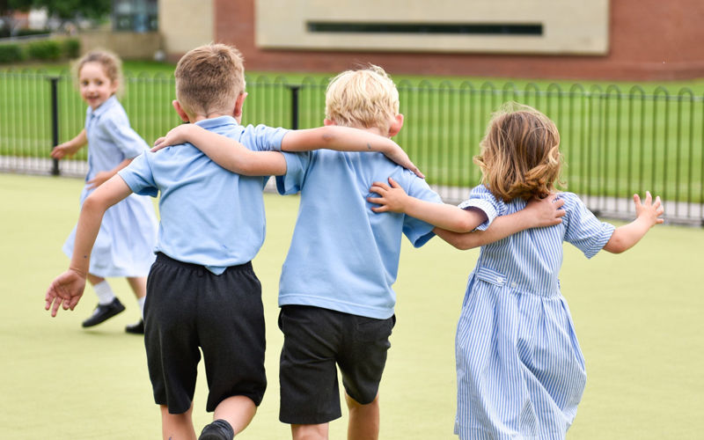

Pendeen

Curriculum Newsletter

Autumn 1st Half term 2021

Maths:

This term we will learn to:

* Learn number songs to help us count
* Recognise and write numerals to ten
* Copy, continue and create patterns using colours and shapes
* We will begin to learn the days of the week
* Chant to 10 and begin to chant to 20

.Literacy:

In English, we will be looking at different stories linked to our topic. The first story we will look at is ‘The Lion and the Mouse’. The children will discuss the story and talk about the animals feelings. The children will have daily phonic lessons using the Read Write Inc. programme. We also practice the letter sounds throughout the day. At this stage we do not teach letter names but we learn the sound phonetically. The children will learn how to form letters and words. Most of their learning in literacy will be linked to the topics where appropriate. You can support your child by listening to them read and encouraging them to write and complete their homework.

Personal, Social and Emotional Development:

The whole school value for this half term is ‘Respect.’ The children will learn what respect means and to be able to recognise situations where respect has been shown. We will link the value to a bible story. We will have weekly circle time, which will help the children understand their own feelings and the feelings of others. We will teach the children how to be independent, they will learn to share and to take turns and to assert themselves in a friendly manner to resolve conflict peacefully. They will learn how to work in pairs and groups with other children that we would not normally play with.

Communication and Language:

The children will continue to learn how to express themselves effectively showing an awareness of the listeners needs. The children will also learn to work in small groups both with and without adult support. They will continue to work with a talk partner when answering ‘how’ and ‘why’ questions.

Physical Development:

The children will have weekly PE lessons. This will enable the children to develop good physical skills in all areas of PE. They will learn the importance of a healthy diet and about the effects exercise has on their bodies. This half term the children will learn to move freely in a range of ways. The children will be working on their fine motor skills, gaining strength in their fingers to aid in their pencil grips for writing. We will learn plenty of fun action songs. The children have plenty of access to the outdoors every day, they use the equipment make up games for themselves.

Understanding the World:

The children will look at similarities and differences between themselves, including eye and hair colour, height and age. The children will be encouraged to take photos of each other and makes comments about who they have photographed and what they like about that person. They will also have regular access to IT equipment.

Expressive Art & Design:

We will provide an adult led art sessions (which are linked to the topic or class story) that will give the children opportunities to learn new skills. The children will work with in pairs to see what happens when colours are mixed. They will make models using their own ideas and a variety of mediums. They will learn songs and dances and how to use musical instruments. The children will express themselves through creative play.

RE

The children will learn the lord’s prayer and the candle prayer. They participate in a daily collective worship. The theme for Autumn one is ‘Creation’ and the children will learn about the creation story.

This list is a brief summary of what we will be covering in the Autumn Term. It may change or include other areas. Please feel free to ask the class staff any questions you might have about the content of the curriculum or any other part of school life.

Please ensure your child has their book bag, water bottle and coat in school every day. On Thursday children need to arrive in their PE kit. Thank you.