Sensational Sports News!

Maths Masters!
Gribbin – Rhyley
Trevose – Amber
Tater Du – Heidi
Longships – Laura
Wolf Rock – Fearne
Writing Wonders!
Gribbin – Danny
Trevose – Adam
Tater Du – Bradleigh
Longships – Alice
Wolf Rock – Campbell
Attendance Achievers!
Gribbin – 100%
Trevose – 97%
Tater Du – 95.9%
Longships – 97%
Wolf Rock – 97.5%

Celebrate the fabulous attitudes, learning and achievements this week!
What can you do to get your name in the newsletter?
Class Dojo Legends!
25 dojos –

Building Learning Power Heroes!
Gribbin – Arlo
Trevose – Florrie
Tater Du – Tora
Longships – Skye
Wolf Rock – Jessica

Stars of the week!
Gribbin – Ruby
Trevose – Tom
Tater Du – Luke
Longships – Harry
Wolf Rock – Fynley
Nurturing God’s gift with compassion and drive so that all our children succeed, learn and thrive.
Compassion, wisdom, forgiveness, perseverance, trust and respect
At Celtic Cross Education, we nurture, we learn, we achieve together.
As you will be aware from your Curriculum Newsletters, the school and children are focusing on keeping safe in school and anti-bullying. The children have been engaged in Collective Worships, lessons and discussions on these issues and as a community, we are becoming more aware of what bullying is and how we can promote a zero tolerance to it. We are in the process of producing a leaflet to support this work but in the meantime, please ask your children what the 2 meanings of S.T.O.P are, and what their understanding of bullying is. Some useful websites are: https://www.anti-bullyingalliance.org.uk
https://www.bullying.co.uk/

In other news this week…

African Drumming
Tater Du and Longships Class were very pleased to welcome Tim Senior into the classroom this week to begin a set of 10 sessions teaching our children how to play a range of African drums. This course of 10 lessons is thanks to First Access Music provided to us by Cornwall Music Education Hub and delivered by Stick-At-It Drumming. Look out for an invitation to a performance towards the end of the sessions!
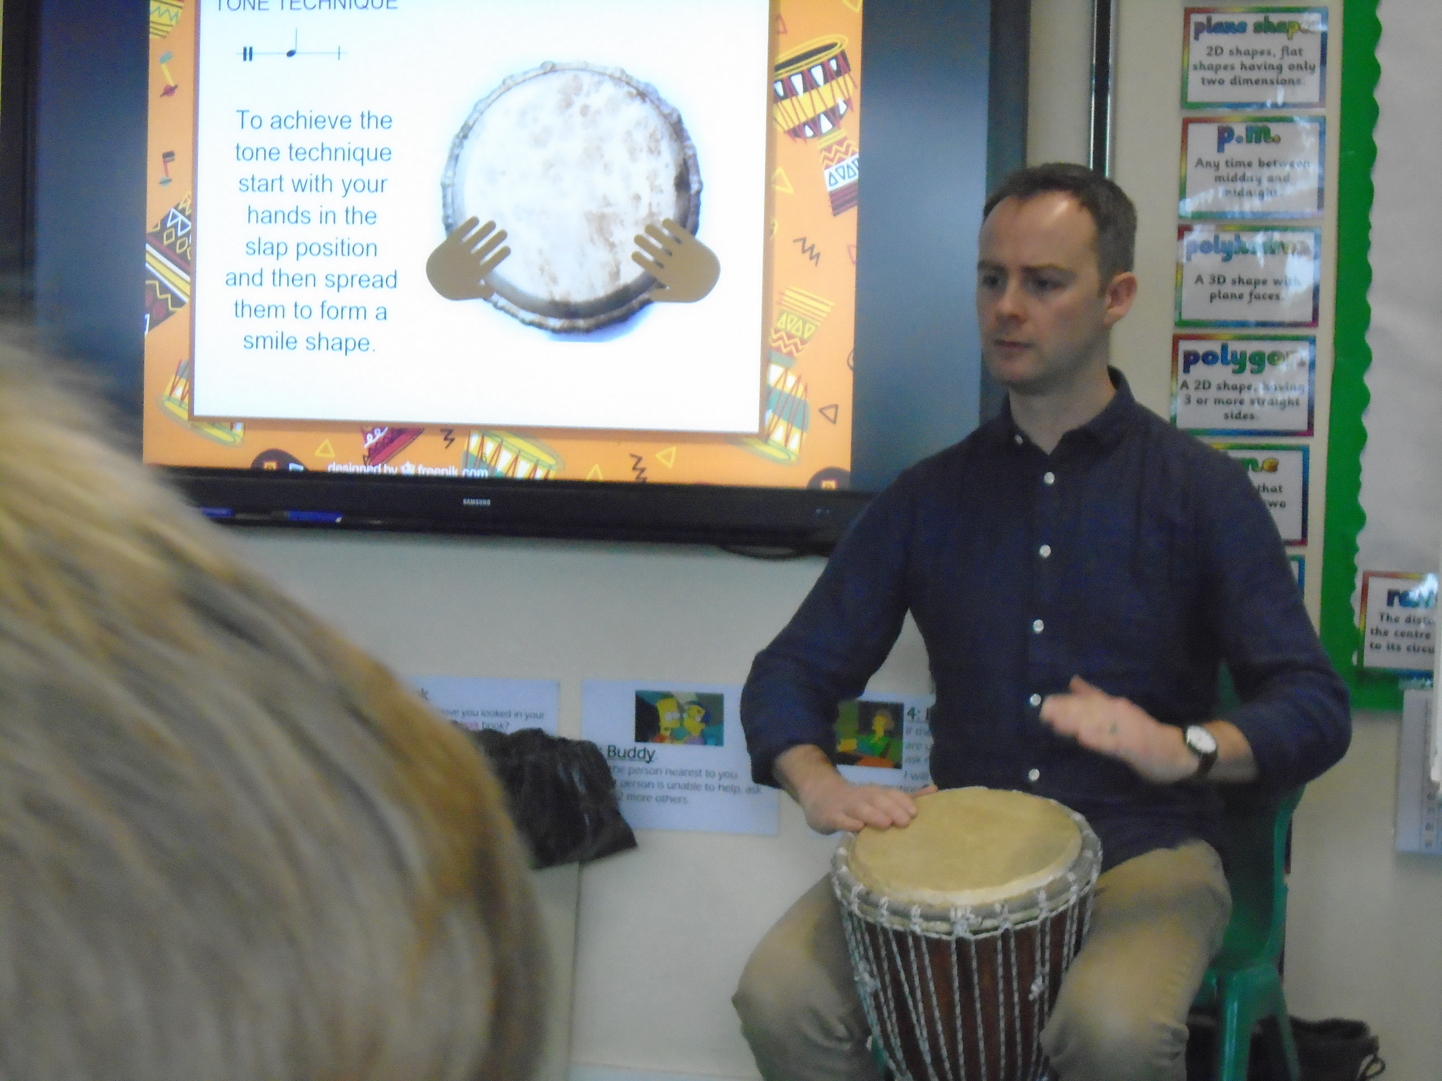
Please remember to follow us @GrampoundRoad on Twitter to find out more.

Instrument Lessons
Please remember that your child can learn to play the drums, guitar or keyboard at school through our peripatetic teachers. Please contact the school office if your child is interested in learning a new instrument.

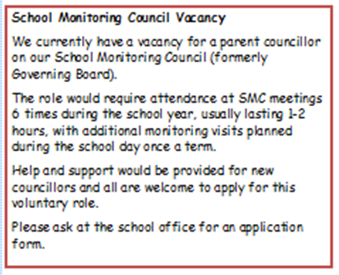
RWI Phonics and Writing
Would you like to find out more about our Reading and Writing scheme?
If so, please follow the link below:
https://www.oxfordowl.co.uk/for-home/find-a-book/read-write-inc-phonics--1/

30/01/19 | No admin staff in school this afternoon
31/01/19 | Hearing re-tests
04/01/19 | Gribbin Class Vision screening
05/01/19 | Safer Internet Day
07/02/19 | Parent Forum 2:30pm
13/02/19 | Netball at The Roseland for Y4,5,6
18/02/19 | Half Term
26/02/19 | WOW Basketball event for selected children at Grampound with Creed
11/03/19 – 15/03/19 | Parent and Teacher meetings
13/03/19 | Open the Book
15/03/19 | Messy Church 5:15pm
20/03/19 | Funfest at The Roseland
02/04/19 | Class photos
05/04/19 | Last day of the Spring Term
23/04/19 | First day of the Summer Term
07/06/19 | INSET day
25/07/19 | INSET day

