Tater Du

Year 3 and 4

Curriculum Newsletter

Autumn 1st Half 2019

Is the lion the King of Africa?



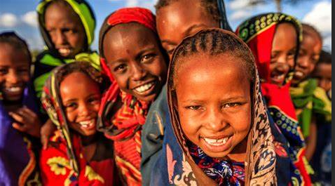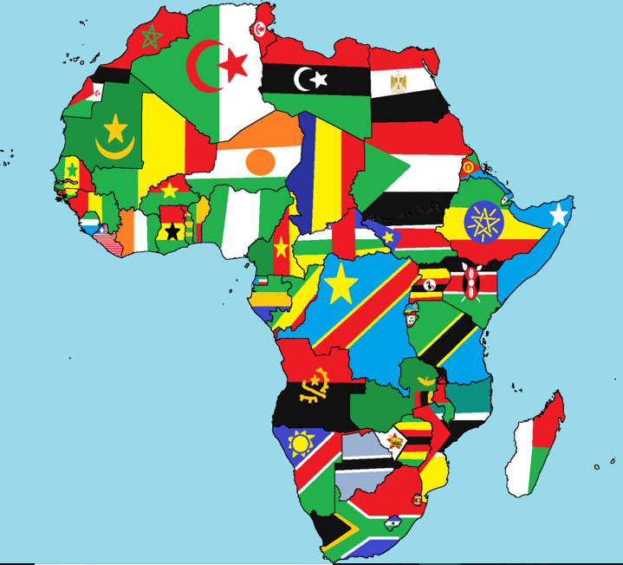

Staff:

Miss Hosking (Class Teacher)

Miss Epsly-Revill (Teaching Assistant)

Mr Ryan Davies (Teaching Assistant)

Mr Webb supports us with P.E. on Fridays

Mr Senior will be teaching us African Drumming on Tuesdays

Tater Du have had an amazing start to the new school year, and we are enjoying working in our new, bright, larger classroom! We are all looking forward to a busy and productive term ahead.

Homework and Spellings:

We will continue to follow the appropriate Spelling Shed in school. **Helping your child to learn their spellings will really make a difference!**

Please continue to record when your child reads and when they practise their times tables and spellings. You can see their previous test results on the current week’s homework sheet.

**Homework will be set on a Wednesday and should be completed by the following Tuesday. Spelling Tests will be completed on TUESDAY. Books MUST be returned to school on TUESDAY so that spelling and times table tests can be recorded on the next week’s Homework Sheet.**

Please contact me if you have any queries about the curriculum or any aspect your child’s education. I look forward to a fabulous term of learning with your child. Many thanks for your continued support.

Topic (including History and Geography)

We will be naming and locating places in Africa and learning about the environment and climate. We will also consider how the environment has an impact on the lives of African people, and look at their art, culture and music. We have also been loaned some incredible books and artefacts from the Education Library Service.

Art, Design and Technology:

In Art we will be developing our drawing skills and will create African masks.

Music:

In Music this half term, we will be learning about Music from different cultures. We are really looking forward to having African Drumming lessons with Mr Senior.

P.E.

P.E. this half term will take place on Wednesday and Friday afternoons. We will be developing our multi-skills (catching, throwing, dribbling etc.) and we will also benefit from Mr Webb’s support on Friday afternoons.

Trips

A letter was sent home this week about our school camp in June 2020 to Porthpean. Some children left their letters at school that evening so I have spares if yours didn’t make it home. I am also arranging a trip in early October to Porfell Wildlife Park to see some African animals and a Maasai village. Please look out for a letter next week!

This list is a brief summary of what we will be covering in the 1st half of the Autumn Term. It may change or include other areas. Please feel free to ask the class staff any questions you might have about the content of the curriculum or any other part of school life.

**To support your child please ensure:**

* **Your child has their P.E. kit in school.**
* **All belongings are clearly named.**
* **Homework and reading is completed.**
* **Reading books and records are available in the school every day.**
* **Your child has weather appropriate clothing**
* **Your child has a named water bottle in school.**

Please encourage your child to be responsible for their own belongings.

Maths:

In Maths this half term, we will focus upon reading, writing, comparing, ordering, rounding and representing numbers. We will also extend our knowledge of number bonds to add and subtract numbers both mentally and using formal written methods. We are using the Text Books and Practice Books from our new Power Maths Scheme, and we teach maths separately within their year groups. We will also continue to include fun investigations and games for the children to enjoy. As before, our ongoing focus is on ‘mastery’, which will include using maths in real life situations. We will be practising our times tables frequently this term, and homework will be linked to this. Please practise with your child if you get the chance, especially with the online program Times Tables Rockstars that we use in school, as this will support them in and out of school! Year 4 children will be the first cohort to take the Government’s new Times Table Test next summer, so it is imperative that they practise them regularly in preparation for this task.

English:

In English, we will be using our topic of Africa to write traditional stories and fables, and we will read Michael Morpugo’s Butterfly Lion in our Guided Reading sessions. We will be writing non-chronological reports and have opportunities to practise our persuasive techniques too. We will be continuing to focus on our handwriting and joining letters and consider more complex grammar and punctuation skills. We will be accessing the online program spag.com once a week. Some children will continue practising their Phonics and spelling in daily Intervention groups.

Science:

In Science, we will be studying Animals and their Habitats, and learn about African plants and animals. They will consider food chains, look at the nutrition in African food, and also learn about our Digestive System.

Computing:

In computing, we will be continuing to practise our word processing skills. The children will regularly use the iPads and complete Maths and Literacy programmes.

Religious Education:

We are currently awaiting our new curriculum for this year, so we will start by focussing upon our key Christian Values of perseverance, compassion, trust, forgiveness, respect and wisdom.