**Staff:**

**Mr Salway (Class Teacher)**

**Mr Jory (Teaching Assistant)**

**Miss Bulley (Teaching Assistant)**

**Homework and Spellings:**

**This term, we will be focusing on a variety of spelling rules, including homophones, using the Spelling Shed scheme. These will be reinforced in your child’s weekly spellings test. Helping your child to learn their spellings will really make a difference!**

**Homework will be set on a Friday and should be completed by the following Wednesday. Spelling tests will be given on a Tuesday, so that they can be marked ready for you to view the results on Wednesday.**

**As always, thank you for your ongoing support.**

Wolf Rock Class

Curriculum Newsletter

Spring Term 2020



Raiders and Invaders:

The Anglo-Saxons and Vikings

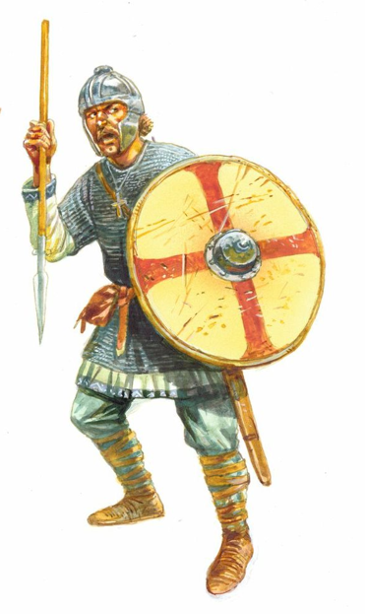

A little taste of what we’ll be doing…

* Exciting Science experiments which allow children to grow mould.
* Anglo-Saxon jewellery making in art.
* An opportunity to exhibit writing in public arenas.

Maths: This term, all children will be looking at fractions, decimals and percentages. In Year 5, children will cover fractions, decimals and percentages as well as multiplication and division. In Year 6, children will cover fractions, decimals and percentages, measure and basic algebra. Children in Year 6 will also have the opportunity to practise for their forthcoming SATS tests. We will be having an ongoing focus of ‘Mastery’ within our lessons using the Power Maths scheme. The scheme will help children to understand Maths using real life situations which will develop reasoning, fluency and problem solving skills. We will also be practising our times tables frequently this term too. Please practise with your child if you get the chance as this will support them in and out of school.

English: For English this term, we will be writing creatively by constructing a Myths and Legends narrative based on our Viking topic. We will also be writing instructions and poetry. We will continue to develop our comprehension skills of different texts during accelerated reading sessions and through whole class guided reading. When reading with your child, see if they are able to spot the nouns, adverbs, adjectives, conjunctions and figurative language, such as simile and metaphor, in their books. This will support their writing in class. We will also be continuing to focus on our handwriting and joining letters, working hard to get our pen licences.

History: This half term, Wolf Rock will take on a fascinating journey, back in time, as they find out about the Viking and Anglo-Saxon struggle for the kingdom of England and how England became a unified country. We will explore where the Anglo-Saxons and Vikings came from, how they fought for territory and power, and how their fighting ultimately led to the kingdom of England we know today. Along the way, they will also find out what life was like for everyday people living in Anglo-Saxon and Viking Britain, exploring things such as Viking runes and Anglo-Saxon stories like Beowulf.

Science: In the ‘Living Things and their Habitats’ unit, Wolf Rock will learn about the classification of living things, including micro-organisms. We will be sorting animals into groups based on similarities and differences. We will learn about micro-organisms and conduct investigations to see how mould grows on bread. Furthermore, children will use play dough to create a single cell micro-organism and explain how it is classified and why.

Art: Children will have the opportunities to use clay in order to create Anglo-Saxon jewellery this half term. We will practise making different kinds of jewellery and research the many designs before debating if colour or intricate detailing had any bearing on the final designs.

Music: This term the children will learn all about the genres Pop Ballads with the assistance of Charanga - an online music teaching platform. Children will learn the lyrics to ‘Make You Feel My Love’ by Bob Dylan and famously covered by Adele..

PSHE: Over the next few weeks, children will continue to work on the unit ‘Getting on and Falling Out’. This theme focuses on developing children’s knowledge, understanding and skills in four key social and emotional aspects of learning: empathy, self-awareness, social skills and motivation. The theme offers children the opportunity to explore feelings and emotions that are displayed when we fall out with our friends and also give children a series of coping tools should this happen.

P.E: Once again, we will have two hours a week of PE this year. For the first three weeks, we will be learning the skills required for Outdoor Adventurous Activity, such as Orienteering. We will play many games which encourage the development and understanding of being able to read bearings and maps. For the next three weeks, we will be in the Gym performing rolls, making balances and shapes. All of this will lead up to the children being able to design and sequence a routine to perform in front of their peers.

Please ensure your child has their P.E. kit in school on a Friday. Thank you.

This list is a brief summary of what we will be covering in the first half of the Spring Term. It may change or include other activities. Please feel free to ask the class staff any questions you might have about the content of the curriculum or any other part of school life.