Homework and Spellings:

Homework will be set weekly and spelling checks will be given on Wednesday. Please continue to hear your child read every night and record it in their reading record. We completely understand this can be time consuming but reading a few pages a night really helps their progress and their confidence.

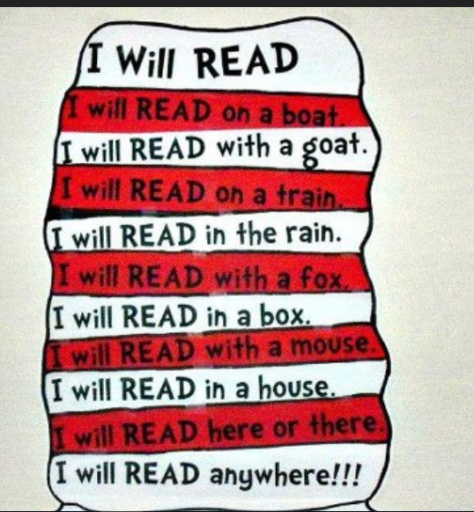

Pendeen and Trevose

Curriculum Newsletter

Spring 2nd half

Explorers and Scientists

Year 1 and Year 2

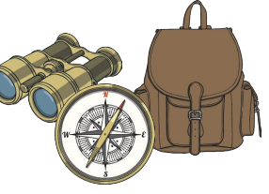

.

Please find enclosed information regarding the learning taking place this half term in Year One and Year Two. If you have any queries about the curriculum or any aspect your child’s education, please speak to your child’s class teacher.

Thank you for your continued support.

Mrs Jones Miss Eastham and Miss Kennedy

Maths: Year 1-We will be working on addition and subtraction, number and place value and measurement. to 20.

Year 2- Multiplication and division, statistics, measurement, geometry and fractions.

English: The children will continue to do daily phonics and writing in Read Write Inc and Get Writing. We will also be doing cross curriculum writing. We will learn The Enormous Turnip story. We will rewrite the story and make our own stories up. We will look at non-fiction texts linked to our science topic of plants and growing. Children will complete SPAG sessions (spelling, punctuation and grammar) and we will continue focusing on handwriting.

Science: we will be learning about different types of plants. Including, garden plants, wild plants and different types of trees. We will plant different types of seeds and bulbs and discuss how they are similar and different. We will be observing how different plants grow and we will be recording our observations over the half term.

Art we will be learning about the artists **Paul Klee and Jackson Pollock** and the techniques they used.

History - We will learn about the great explorers Christopher Columbus and Robert Falcon Scott. We will discuss and learn how some of these great explorers have helped us to understand more about the world and beyond. The children will write a message in a bottle and a diary entry.

Religious Education:

The children will learn that Easter is a festival that occurs in spring to remember a very important part of the Bible. They will learn that Christians celebrate the birth of Jesus at Christmas. Christians believe that Jesus is God who come to Earth. The life of Jesus and many things he said and did are found in the Gospels in the Bible. The Easter story is one of sadness, followed by great happiness.

Music: The learning is focused around two songs: Rhythm In The Way We Walk (Reggae style) and The Banana Rap (Hip Hop style). You will Listen & Appraise other styles of music and continue to embed the interrelated dimensions of music through games and singing.

Computing:

The children will learn about safety and how to keep personal information safe.

P.E. will take place on Thursday and it will be orienteering.

To support your child please ensure:

* Your child has their P.E. kit in school.
* All belongings are clearly named.
* Book bags are brought into school daily.
* Your child has a coat with a hood in school.
* Homework books and reading record books are available in the book bags.
* Please encourage your child to be responsible for their own belongings.

.