

St Piran’s Post

November 2015 Edition

**ISSUE 3**

**j0343163j0343163‘Nurturing God’s gifts with compassion and drive, so that all our children succeed, learn and thrive’**

**St Piran’s Cross will remember those who sacrificed so much for our futures in all wars during the week of the 9th November 2015**

Dear Parents,

We hope you and your family enjoyed the half term break.

Once again thank you for all of your support for our schools during the first half term, this is much appreciated. A positive start has been made to our teaching and learning and I know that some of you have already met the teachers, and others will do so early this month.

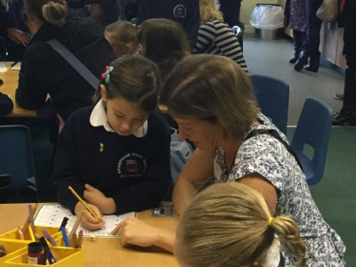Your help and support with your child’s learning is much appreciated and we hope that you will find time to sit down and discuss the targets agreed with the class teacher.

**Remembrance Week at St Piran’s Cross MAT**

**Week of the 9th November 2015**

****We will be supporting the annual Royal British Legion Poppy Appeal during the week of the 9th November and our collective worship etc will focus on ‘**remembering’.**

We will hold a minute’s silence in our schools at **11 am on Wednesday 11th November 2015**.

**Open Mornings in October 2015**

I am delighted to tell you that **178** parents attended the St Piran’s Cross MAT Open Mornings during October 2015. The general feedback from parents was that these were worthwhile and helpful.

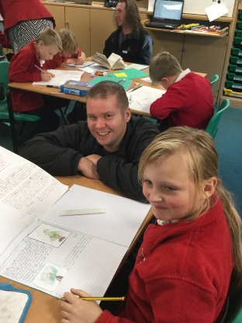I would like to thank our Heads and staff who worked hard to ensure that you could see how the children learn during the school day. I am sure that you would like to join with me to thank them for this!

**Below are some photos of parents supporting their children’s learning.**

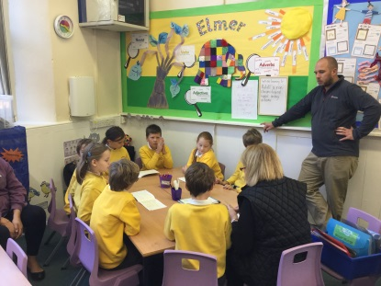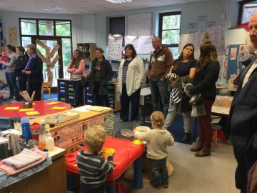

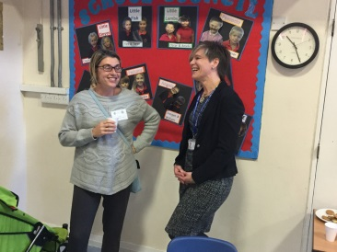

**Parents visiting our classrooms**

**Parent Forums – second one this term**

Parents are invited to attend one of our parent forums this term. Please note this is not a meeting to discuss individual children as this should be addressed to the class teacher in the first instance. The Head and I hope to attend each meeting and look forward to a discussion with you over a cup of tea.

The dates and times of each forum can be found below:

Bishop Bronescombe CE- **17th November at 2.15 pm**

Ladock CE – **10th November at 2.15 pm.**

Grampound with Creed – **12th November at 2.15 pm**

Grampound Road – **11th November at 2.15 pm**

Veryan – **13th November at 2.15 pm**

**Residential Visits for Year 4, 5 and 6**

We have now finalised all of our residential opportunities for Year 4 ,5 and 6 pupils and will be holding ‘Information Meetings’ for Parents to attend in each school to find out about each trip. A letter will also be sent home on Friday 6th November.

**The residentials are:**

* **Year 4** – one night and two days at Camp Kernow in Truro
* **Year 5** – Two nights and three days at Porthpean Residential Camp, St Austell
* **Year 6** – 4 nights and 5 days at Barton Hall, Devon – Outdoor Pursuits and adventure.

The meetings to explain each trip are as following

* **13th November at 3.30** – Veryan CE
* **16th November at 3.30** – Grampound Road CE
* **17th November at 3.30** – Bishop Bronescombe CE
* **19th November at 3.30** – Grampound with Creed CE
* **20th November at 3.30** – Ladock CE

We will explain each trip at the one meeting and answer your questions. Although these are planned as a MAT residential, each school will keep its own identity and space and the children will remain in school groups with their friends and staff they know. They will of course have opportunities to mix and get to know each other as well.

**MAT INSET Days**

The staff of our five schools came together on Monday 2nd November to receive **THRIVE training.** This was an enjoyable and helpful training session.

**What is the Thrive approach?’**

‘Thrive helps adults prepare children and young people for life’s emotional ups and downs.

The Approach teaches us how to be, and what to do, with children’s differing behaviours.

Our next INSET Day is on **Friday 4th December 2015** and will focus on ‘**Read, Write Inc’** for Key Stage 2 children. It will help us to review our teaching of spelling, grammar and punctuation in Year 3 to 6.

**Christmas at St Piran’s Cross MAT**

Our schools are currently planning their Christmas events and will let you know about the dates and times of these in the weekly school newsletter. This year we will be holding one event for the MAT and this will be our Christingle Service for Year 4 , 5 and 6.

This will take place on **Monday 7th December 2015** at the Holy Trinity Church in St Austell. Each school will make a contribution to the service and we will be raising funds in aid of the Children’s Society.

**Unfortunately the church is not big enough to invite parents but I hope that we can record the service and put it on our website.**

I am also hoping that we will sing the new St Piran’s Cross anthem – ‘Guardian’ at this service.

**Bonfire Night – Thursday November 5th 2015**

C:\Users\LeesM\AppData\Local\Microsoft\Windows\Temporary Internet Files\Content.IE5\PPNLZ3B1\MC900331451[1].wmfAttending an organised event is always safer, however if you are having a display at home we thought this advice might be helpful.

## Always follow the firework code:

* Stand well back
* Keep pets indoors
* Keep fireworks in a closed box
* j0185788Only buy fireworks marked BS 7114
* Light at arm's length, using a taper
* Follow the instructions on each firework
* Never give sparklers to a child under five
* Don't drink alcohol if setting off fireworks
* Always supervise children around fireworks
* Light sparklers one at a time and wear gloves
* Never put fireworks in your pocket or throw them

**Never go near a firework that has been lit - even if it hasn't gone off it could still explode**

**C:\Program Files\Microsoft Office\MEDIA\CAGCAT10\j0299587.wmfCold Weather Routine or other emergencies**

At this point of the year as the weather begins to turn colder it is worth reiterating our cold weather and emergency closures plans.

There may also be a need for a part closure if some members of our staff cannot travel safely into our schools.

**In the event of severe weather or another emergency we would follow this procedure:**

* We will inform the local radio stations that the school will not be open.
* We will place an information notice on the front page of the school website with the latest information.
* We will text all parents with our intention to close the school.
* A board will be placed at the school entrance to inform people arriving.
* The phones will be manned by staff who live in close proximity to the school.
* If we have to close the school during the working day we will telephone all parents, and staff who live in close proximity to the school will look after them until they are collected.

We hope that this will not be necessary but it is better to be prepared and warned.

**Dates for diaries:**

5th November – **Bonfire Night** – keep safe!

Week of the 9th November – **Parent Forums**

11th November – **St Piran’s Cross MAT Remembers** at 11am.

13th November – **Children in Need Day**

Week of the 16th November – **Road Safety Week**

1st December – **Advent Collective Worship**

4th December – **MAT INSET Day**, staff working on Read Write Inc, spelling and grammar for Key Stage 2 children.

7th December – St Piran’s Post December edition sent out.

7th December – **MAT Christingle Service** for Year 4,5 and 6 in aid of the Children’s Society, details to follow.

18th December – end of term

4th January- Schools re-open for the Spring term 2016

**When I am in school**

You will hopefully notice that I am in school at least twice a week and try to be out and about when parents are on the playground. Do feel free to come and find me to ask questions, express concerns or make suggestions. Thank you.

Yours sincerely,

**Mr. M.J Lees**

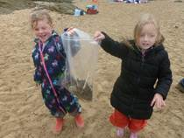**Executive Principal**

**Exciting learning at Ladock CE Primary School**

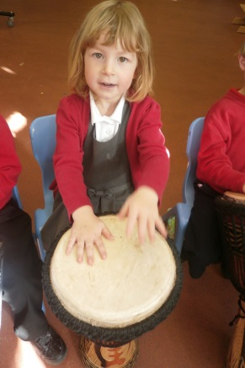Here are some photographs of Cuby class at Ladock having a great time during our recent African drumming workshop. They had all made their own instruments/shakers to use in the session. Andrew Nicholson used 'A Rumble in the Jungle' book to teach them some rhymes about animals which live in Africa, and this has developed into some good non-fiction writing in Talk for Writing sessions.

**Activity Week at Grampound Road CE**

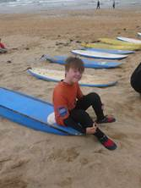At Grampound Road Primary School we have taken part in an amazing activity week just before half term.  The focus of the week was learning about the importance of physical activity/ sports and its impact on our health and lives. The children have been team building with their class members and staff have got to know pupils really well.  The children have participated in a variety of activities: farm visit, surfing/beach day, picnic at the park, scooter/bike obstacle course, Zumba, Just Dance, sport festival and dodgeball.

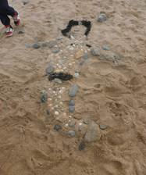Great fun has been had by all pupils, staff and parents who attended these events, challenging themselves with new skills and experiences.