

St Piran’s Post

October 2015 Edition

**ISSUE 2**

**C:\Program Files\Microsoft Office\MEDIA\CAGCAT10\j0298897.wmf****‘Nurturing God’s gifts with compassion and drive, so that all our children succeed, learn and thrive.’**

**Thank you for all of your support in our schools during the first few weeks of this term.**

Dear Parents,

Our schools have been very busy during September and later in this newsletter you can read about some of the exciting things they have been doing. Thank you to the parents who attended our **PARENT FORUMS** and we will be inviting you to another one of these later in the term. We do take some of the comments and questions raised and where possible respond to these issues.

I hope to see lots of you at our school **OPEN Mornings** this month when you can come and see how your child is learning and being taught. We will serve tea and coffee and the Head and I will be available throughout the morning.

**Behaviour and attitudes in our schools.**

We will be expecting hard work, effort, good manners and excellent behaviour from all of the children.

We live our school lives by the **St Piran’s Cross Teaching and Learning Principles** **for Behaviour.**

We thought it would be helpful if you knew what we expect of each child?

**In my classroom I will:**

* Work **collaboratively.**
* **Persevere** at my work - I will never give up.
* **Show resilience** - I won’t worry if I am stuck or need to change things. I will aim to improve.
* Aim to work **independentl**y wherever possible.
* **Manage my distractions** to make sure my learning is the best it can be.
* Be **resourcefu**l (if I am stuck I will think first, use displays/resources, ask my partner and then ask a teacher if I still don’t know the answer – ‘Four Before Me’).
* Demonstrate my **good attitudes** to learning.
* **Respect** the opinions and beliefs of others.
* Be helpful and kind to others.
* **Listen** to adults and other children when they are speaking.
* Remember my manners and be polite at all times.
* Make the right choices about the behaviour I show in class.
* Always work my hardest so that I achieve the best work possible for me.

**Around my school I will:**

* Walk in the corridors at all times.
* Hold the doors open for all adults and other children.
* Remember my manners and be polite at all times.
* Make the right choices about the behaviour I show in and around the school.
* Use a quiet voice when walking around the school.
* Keep the school environment clean and tidy.
* Respect the school property and my own.
* Eat sensibly and politely at lunch time and help to keep the dining area clean and tidy.
* Stop everything I am doing and stand still and in silence if I hear the whistle or the bell.
* Listen to the instructions from the adult in charge.
* Respect the equipment and other children.
* Make the right choices about the behaviour I show in the playground.
* Tell an adult if I see behaviour I do not think is right or if I feel uncomfortable about something.
* Line up sensibly
* Ask permission from an adult before going inside school.
* When in quiet areas and on paths, walk sensibly.
* Put all litter in the bin.
* Be kind to all other childrenMCj04376710000[1]

**Food Standards Agency Expectations**

Our Trust schools have now signed up to, and we hope will meet, the Food Standards Agency’s expectations of schools. Thank you for doing your part by following our food to school for breaks policy, this is much appreciated. Chartwells, our lunchtime caterers, already meet these expectations.

We do need to look carefully at some of our school tuck shops and whether they meet requirements. This will be our task in coming weeks. We are not spoil sports and there will be times when we have a treat!

Just to remind you all:

* Foundation Stage and Key Stage 1 children will be provided with a free piece of fruit each day. The government pays for this.
* **Key Stage 2 children** may bring a piece of fresh or dried fruit to school to eat at playtime. They may also bring milk or fresh water to drink. **These are the only snacks that children are allowed to eat at our schools during break times.**

**HARVEST FESTIVALS**

These are planned for:

* **Bishop Bronescombe -** 5th October at 9.15 am
* C:\Program Files\Microsoft Office\MEDIA\CAGCAT10\j0233312.wmf**Grampound Road** – 6th October at 9.15 am
* **Grampound with Creed** – 8th October at 9.15 am
* **Ladock** – 9th October at 9.15 am
* **Veryan** – 7th October at 9.15 am

**Details of each event will follow within each school’s newsletter.**

**SCHOOL OPEN MORNINGS**

**Come and see your children learning. ALL welcome, including aspiring new parents to our schools:**

* **Bishop Bronescombe -**12th October at 9 am to 11.45 am
* **Grampound Road** – 16th October at 9 am to 11.45 am
* **Grampound with Creed** – 14th October at 9 am to 11.45 am
* **Ladock** – 13th October at 9 am to 11.45 am
* **Veryan** – 15th October at 9 am to 11.45 am

**News from our Schools**

**Ladock School**

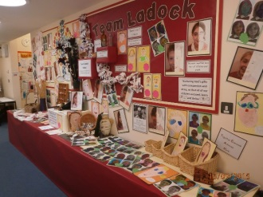It was wonderful to see the children after the six week break. They were all looking incredibly smart despite there being some delays in uniform orders coming through.

They were delighted to see their pictures forming part of Mark Lees’ beautiful, ‘Team Ladock’ display which now lines our entrance corridor. We already have some new children who have just started at the school who will need to add their pictures bringing our current total to 86 including the nursery.

Read, Write Inc is now firmly underway with six groups taking place first thing each morning as well as the older children taking part in reading, spelling, grammar and punctuation activities. Talk For Writing fiction units are also underway in all three classes and we are looking forward to our first story telling competition next week

**Grampound Road School**

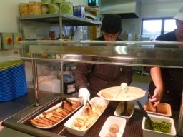A great start has been made at Grampound Road CE Primary School.

**What’s new at Grampound Road Primary School in 2015:**

1. New classroom for Year 6 and new furniture and resources for the Reception Class, the children are thoroughly enjoying their new learning environments.
2. New school website is up and live with up to date information and the children writing a weekly blog from each class.
3. New amazing kitchen – well done to the kitchen team for making delicious school dinners which the children and staff are enjoying. The children are now able to choose salad and enjoy meals which are hotter and fresher in quality.
4. New library is being created for the children which is a calm place to work and read.
5. The children have been learning drumming with Mr Senior from Year 1 to year 6.

**Veryan School**

**Veryan Village Autumn Show**

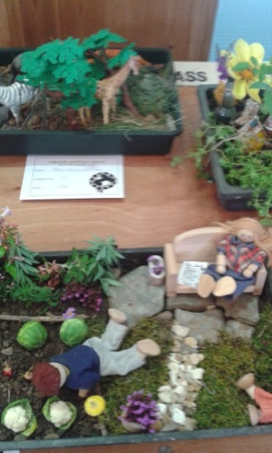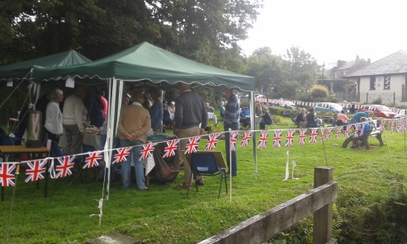

The Veryan Village Autumn Show took place on Saturday 19th and the school was fully involved in this event. The entries were magnificent and it was pleasing to see how many of our children entered the competition. Well done to all of these and those that gained the coveted 1st, 2nd or 3rd stickers.

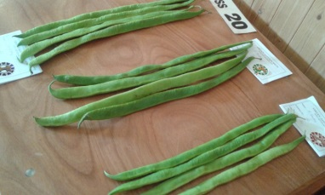Unfortunately, Mr Philips, the Head of School’s jam did not win a prize this year. He will try harder in 2016.

Mr. Lees had thought about entering his runner beans until he saw the standard this year! Wow!

**Bishop Bronescombe School**

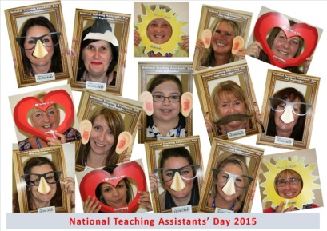A positive start has been made to the new term at Bishop Bronescombe and the children are settled and working well. Our new staff are already making an impressive contribution to our school.

On Wednesday 16th September we celebrated **National Teaching Assistant Day.**

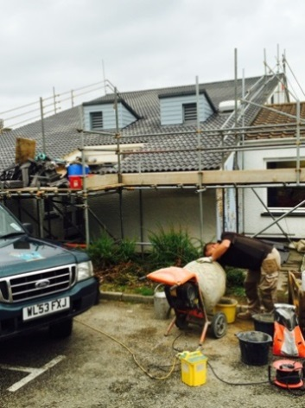We held a special assembly with all our TAs as VIPs! Children and staff shared memories and stories of how important their TA is and the difference they make in our school. Each TA was given a sticker and a balloon and we snapped a photo of them for our website. We prayed for all our TAs and their families and they continue to be blessed throughout the school year.

**A New Roof for BB!**

The roof has been finished and was officially handed-back on Monday 14th September. The new tiles and dormers look fantastic and we can look forward to a leak-free winter ahead of us.

**Grampound with Creed**

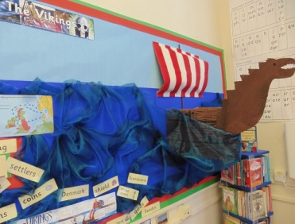We have had a very positive start to the year with staff, pupils and parents feeling refreshed and enthused. We are especially pleased with our learning environments across the school which are the result of both Gloweth’s decorators and some extremely hard work from the teaching staff. The whole school has had a ‘face lift’ and now feels light and airy with many beautiful displays. Our outside spaces will continue to be cared for with input from the children and there are plans afoot to develop the courtyard area which is currently rather underused as a storage space.

**Residential Visits for Year 4, 5 and 6**

We are currently finalising the details of our residential offer in the summer of 2016. Schools will send you the details of these opportunities shortly after the half term break.

**Dates for diaries:**

Week of the 5th Oct – **Harvest Festivals**

Week of the 12th Oct – **Open Mornings**

26th to 30th October – HALF TERM

2nd November – **MAT INSET DAY** – focus for staff will be THRIVE training.

3rd November – November **St Piran’s Post** sent out

5th November – **Bonfire Night** – keep safe!

6th November – School Council Conference, all of our school councils at Grampound Road for the day.

Week of the 9th November – **Parent Forums**

11th November – **St Piran’s Cross MAT Remembers** at 11am.

Week of the 16th November – **Road Safety Week**

20th November – **Children in Need Day**

Week of the 30th November – **Decorations Day –** Parents welcome in school to help with preparations for Christmas. Details to follow.

1st December – **Advent Collective Worship**

4th December – **MAT INSET Day**, staff working on Read Write Inc, spelling and grammar for Key Stage 2 children.

7th December – St Piran’s Post December edition sent out.

11th December – **MAT Christingle Service** for Year 4,5 and 6 in aid of the Children’s Society, details to follow.

18th December – end of term

Yours sincerely,

**Mr. M.J Lees**

**Executive Principal**