**Staff:**

**Mr Salway (Class Teacher)**

**Mr Jory (Teaching Assistant)**

**Miss Bulley (Teaching Assistant)**

**Homework and Spellings:**

**This term, we will be focusing on a variety of spelling rules, including homophones, using the Spelling Shed scheme. These will be reinforced in your child’s weekly spellings test. Helping your child to learn their spellings will really make a difference!**

**Homework will be set on a Wednesday and should be completed by the following Monday. Spelling tests will be given on a Tuesday, so that they can be marked ready for you to view the results on Wednesday.**

**As always, thank you for your ongoing support.**

Wolf Rock Class

Curriculum Newsletter

Autumn Term 2019



Crime and Punishment:

Is the Justice System fair?

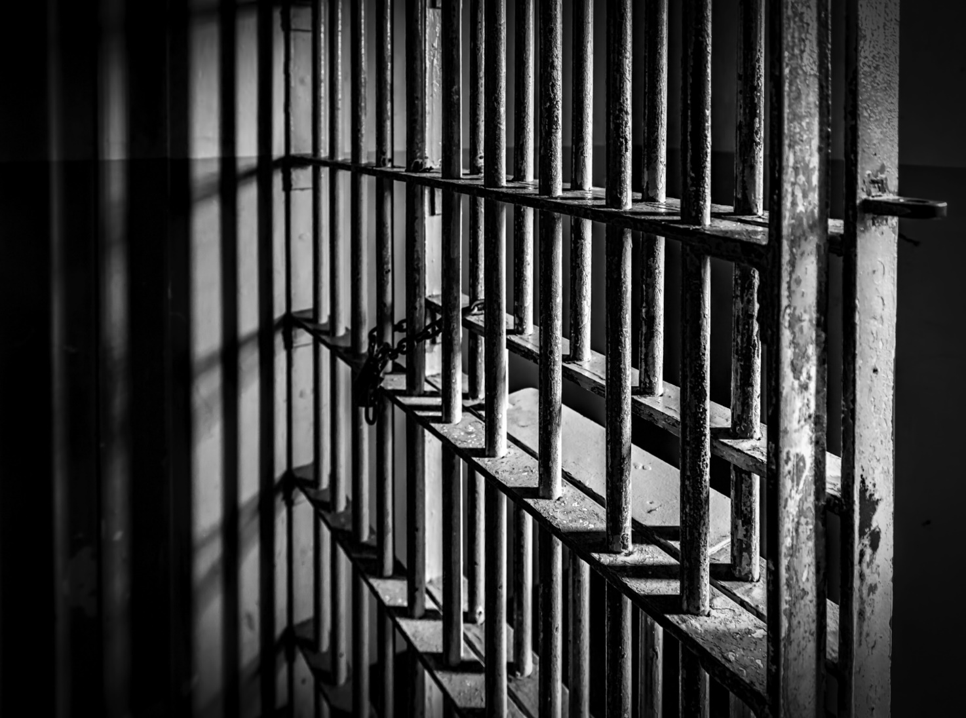

A little taste of what we’ll be doing…

* Exciting days lined up: a trip to Bodmin Jail and a visit from the Police
* A chance to look at crime and punishment from key periods in history including the Roman, Medieval and Victorian eras through to modern day
* An opportunity to exhibit artwork inspired by Banksy in our Wolf Rock Gallery

Maths: This term, all children will be looking at Place Value. In Year 5, children will cover place value to one million, addition and subtraction, graphs and tables, multiplication and division, measurement and perimeter. In Year 6, children will cover place value to ten million, the four operations, fractions and geometry. Children in Year 6 will also have the opportunity to practise for their forthcoming SATS tests. We will be having an ongoing focus of ‘mastery’ within our lessons using a new Power Maths scheme. The scheme will help children to understand Maths using real life situations which will develop reasoning, fluency and problem solving skills. We will also be practising our times tables frequently this term too. Please practise with your child if you get the chance as this will support them in and out of school.

English: For English this term, we will be studying the poem, The Highwayman by Arthur Noyes in keeping with our Crime and Punishment theme, Following, we will be learning the skills to write a formal persuasive letter, which will include technical vocabulary, viewpoints and bullet points/numbering. Our final section will be writing a newspaper report following a break in at the school. We will continue to develop our understanding of different texts during accelerated reading sessions and whole class guided reading using VIPERS. When reading with your child, see what nouns, adverbs, adjectives, conjunctions and figurative language, such as simile and metaphor, they can find in their books. This will support their writing in class. We will also be continuing to focus on our handwriting and joining letters, working hard to get our pen licences.

History: This will be linked with our Science and English. Over the first half term, we will focus on adaptation and evolution, looking at key figures from the past. We will learn about their theories and the impact their research has had on society in the past and today.

Science: This topic will revise the children’s understanding of electricity, starting with revising simple circuits before progressing to lots of hands on experience. Children will understand more about the symbols and diagrams used in electronics before investigating the effect of wire length in a circuit.

Art: Children will further extend their understanding of art by researching the street artist Banksy. By creating stencils and selecting bright and bold colours, children will create their own graffiti tag and have the opportunity to showcase their work within the Wolf Rock gallery which will be open to parents later this year.

Music: This term the children will learn all about the genres Classic Rock and Pop with the assistance of Charanga, an online music teaching platform. Children will learn the lyrics to ‘Livin On A Prayer’ by Bon Jovi and ‘Happy’ by Pharrell Williams.

PSHE: Over the next few weeks, children will study the unit ‘New Beginnings’. This theme focuses on developing children’s knowledge, understanding and skills in four key social and emotional aspects of learning: empathy, self-awareness, social skills and motivation. The theme offers children the opportunity to see themselves as valued individuals within their community and to contribute to shaping a welcoming, safe and fair learning community for all. Throughout the theme, children explore feelings of happiness and excitement, sadness, anxiety and fearfulness, and learn shared models for ‘calming down’ and ‘problem solving’.

P.E: Once again, we will have two hours a week of PE this year. For the first six weeks, we will be learning the skills and tactics of many invasion games such as football, rugby and netball. We will also be applying the tactics of one sport when playing a different game for example, applying defending tactics from football when playing ultimate Frisbee. Children will have the opportunity to represent the school in numerous fixtures this year. Please check out the newsletter for more information.

Please ensure your child has their P.E. kit in school on a Wednesday and Friday. Thank you.

This list is a brief summary of what we will be covering in the first half of the Autumn Term. It may change or include other areas. Please feel free to ask the class staff any questions you might have about the content of the curriculum or any other part of school life.