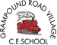
Tater Du’s May half-term Home Learning Activities
Our topic this coming term will be Blue Abyss

Research  Use a dictionary to help you write definitions for the topic-related words listed.  l adaption l aquatic l marine  l ocean l oceanography  l pollution l sea l species | Five oceans  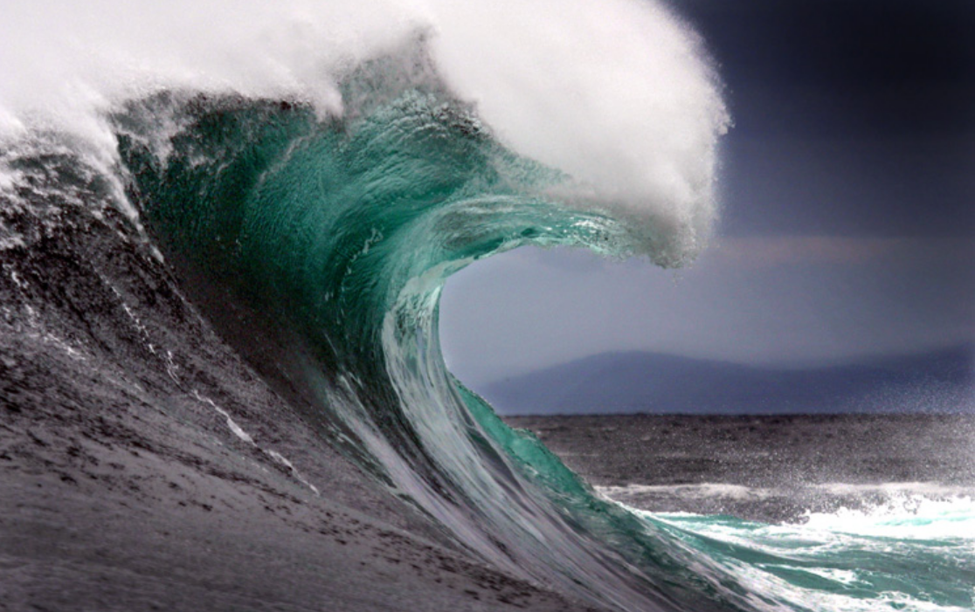  Use online sources or information books to find out about the world’s five oceans. Record your findings and include information about each ocean’s size, temperature, characteristics and animal life. | 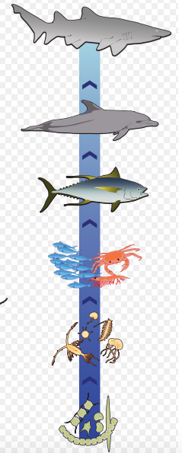  Food chain  Marine species rely on each other as a food source. Answer the questions, then draw some marine food chains.  • What is a food chain?  • What is the producer in a food chain?  • What is the consumer in a food chain?  • What are a predator and prey?
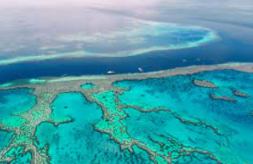  Questions  • What is the Great Barrier Reef an important structure?  • How has the Great Barrier Reef changed over time?  • What threatens the Great Barrier Reef?  • What impact are the dangers and changes to the reef having on other living things that inhabit the area? | 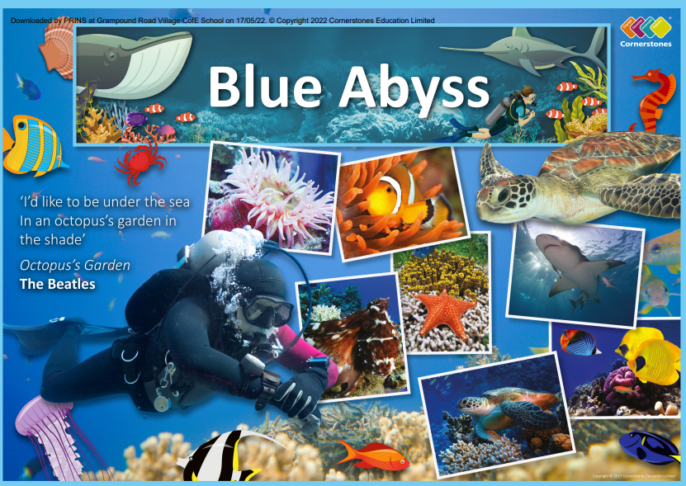 | Unusual marine animals  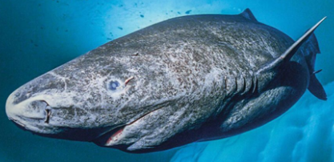  Find out about unusual marine animals, such as the deep-sea angler fish, the gulper eel or the Greenland shark. Draw sketches of the animals that interest you and write a short paragraph to explain the adaptations that help them survive in a particular ocean or ocean zone.
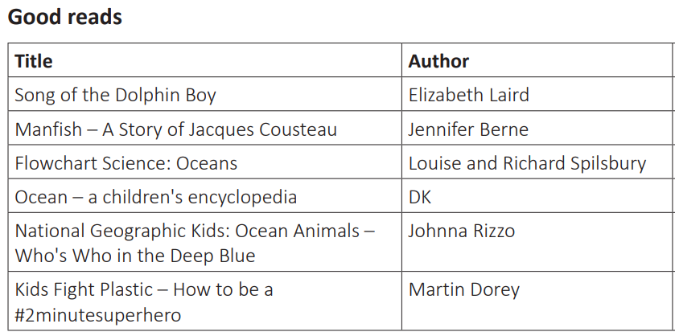 | Art  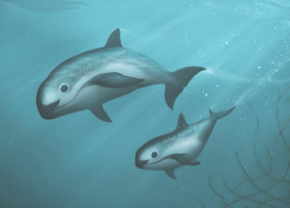  Look at marine artwork by artists, such as Amber Marine, Jenny Berry and Michael Hoffman. Choose an artist whose work you like and use their style as inspiration for creating a marine-inspired artwork. Consider elements of shape, line, pattern and colour when creating your piece. | Useful websites:  National Geographic – Ocean Wildlife  WWF Australia – The Great Barrier Reef  Linda Hall Library – Cornelis Drebbel  Dive & Discover – The Challenger Expedition  Britannica Kids – Jacques Cousteau Kids – Homework Help National Geographic – DEEPSEA CHALLENGE Expedition – James Cameron  Greenpeace UK – Ocean sanctuaries

