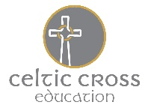
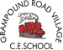
Tater Du’s February Home Learning Activities
Our topic this term will be: Tremors!

Volcano facts!  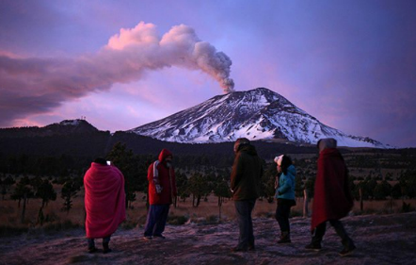  Visit National Geographic for kids and find out 17 explosive volcano facts!  https://www.natgeokids.com/uk/discover/geography/physical-geography/volcano-facts/ | 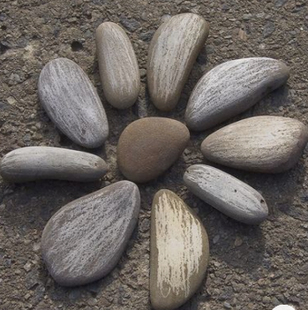  Rocky road  The Earth’s crust is made up of many different kinds of rock.  Go on a walk and see what different rocks you can find. Take some pictures to post on Class Dojo!  If you find any interesting or unusual rocks, please bring them in after half term. | Volcano poetry!  Can you make a volcano acrostic poem? You use the letters for the word volcano to write something about the topic.  Here’s an example (a poem about the sun)  Sunburn is bad for your skin.  Use sunscreen on bright days.  Never stay in the sun too long.
Poster  Design a poster to show a volcano’s main features.  Make sure you label its important parts.  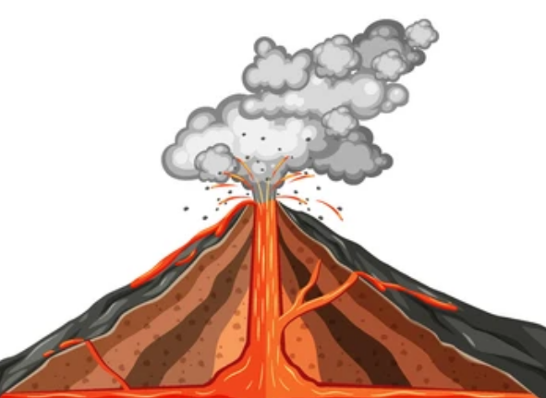 | Tremors!  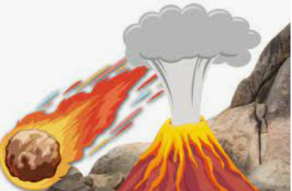 | Imagine  Watch the short clip on BBC bitesize Earthquakes KS2 then imagine you have just survived an Earthquake.  Write a short story about what happened. Make sure you use some factual information relating to earthquakes.
Research  Ask an adult to help you do some research and find the answer to the following question:  What is a Richter scale? | A slice of the Earth’s crust  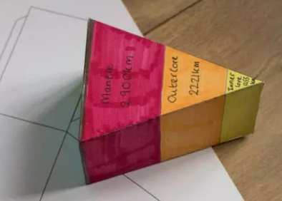  Make a slice of the Earth’s crust!  See the template attached and colour some of the layers of the Earth (you might need to do a little research on this – BBC Earthquakes KS2 is helpful. | Erupting Volcano!  With an adult, create a mini erupting volcano using baking soda and vinegar. Wow!  Take a picture and post in Class Dojo to show how you did it.
