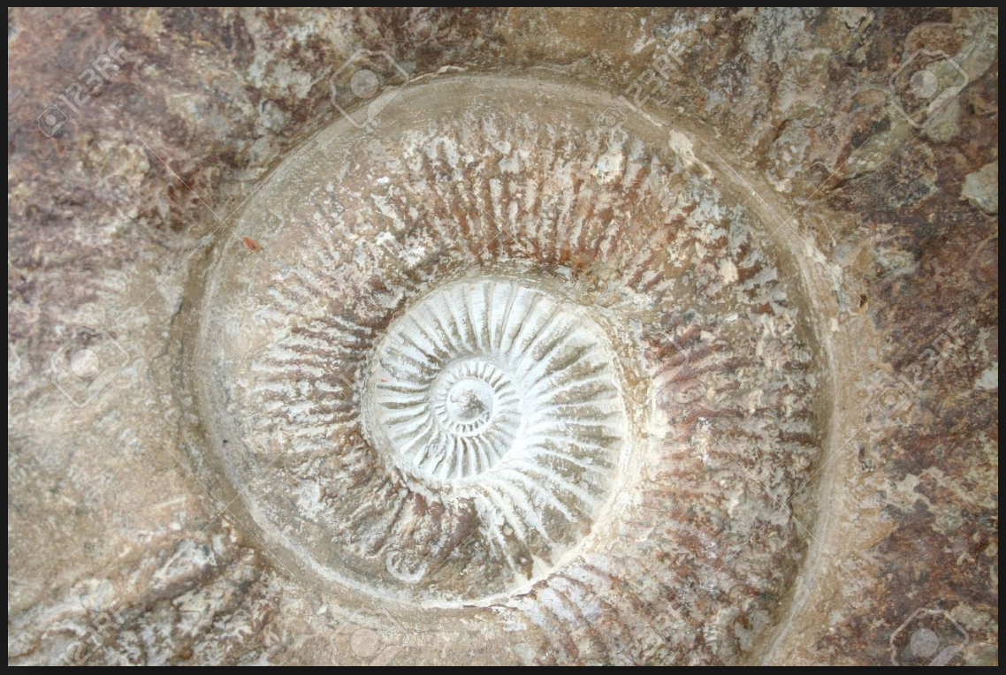
Tater Du homework project for Easter
Next half-term our topic is Geology rocks!
We are looking forward to learning all about different rocks and fossils and investigate how different rocks are formed. We worked together to create our homework grid ready for our next topic, what activity will you choose to complete over the Easter holidays? I can’t wait to see the different things everyone complete!
Science/ literacy  Visit a beach and see what different types of rocks you can find. Can you make a fact file of all the different rocks? | DT/Art  Create a model of the Earth’s layers. What different layers are there from the top soil to the core of the Earth? | History:  Research different mines in Cornwall. What interesting information can you find out? | DT:  Draw and make a model of different precious stones. Is there anything interesting you notice?
Literacy:  Can you make your own salt crystal? What colour will you choose?  Write a set of instructions for someone else to make your own | Question!  Are dinosaurs real?  What information can you find out to prove your answer! |  | Geography:  Go for a walk through your local park/woods and see what different rocks you can find. Take some pictures and sort them into different groups.
Art/DT:  Create a model of a landscape from the Jurassic era. What kind of fossils might be left behind to be found today? | Literacy:  Create a fact file for a famous fossil collector. What can you find out about their collection? How did they find their fossils? | Science:  What are the different types of rocks? Create a diagram/model to explain how they are formed and how they are different. | Science:  How are fossils formed? Can you create an informative poster to explain how fossils are formed over years?

