**Staff:**

**Mr Dave Salway (Class Teacher)**

**Mr Phil Jory (Teaching Assistant)**

**Homework and Spellings:**

**This term, we will be focusing on a variety of spelling rules, including homophones, using the Spelling Shed scheme. These will be reinforced in your child’s weekly spellings test. Helping your child to learn their spellings will really make a difference!**

**Homework will be set on a Friday and should be completed by the following Wednesday. Spelling tests will be given on a Friday so that you can view the results the same day.**

**As always, thank you for your ongoing support.**

Wolf Rock Class

Curriculum Newsletter

Autumn 2 2020



World War 2

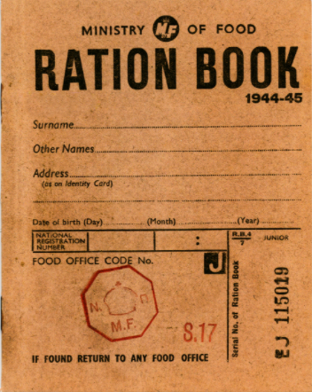

A little taste of what we will be doing…

* Building an Anderson shelter
* Creating a Government poster
* Making a torch

Maths: within this subject, we will be covering: •

* Multiplication and division
* Fractions •

English: in writing this half term, we will be using the text ‘The Old Mill‘ as the stimulus to write a story containing suspense. We will also write:

* Remembrance poetry
* A letter written from the point of view of an evacuee

History: over the next few weeks, we will:

* Identify the time period when the war happened
* Look at how the war started and the impact this had on Europe.
* Unearth the meaning of The Blitz. What was this? What measures were taken to keep people safe?
* What does it mean to be an evacuee?
* Compare and contrast to understand how life has changed since 1945.

In Science, over the next few weeks, we will:

* Learn to represent circuits using symbols in a diagram.
* Research two famous scientific inventors in the field of electricity - Edison and Tesla
* Develop an understanding of what electricity is and how it is measured.
* Plan and conduct investigations recording data accurately and appropriately.
* Design and create a torch.

Art and DT: We will have the opportunity to study the Government posters and design our own modern day version using recycling as the focus. Children will also have the chance to design and build an Anderson shelter using junk recycling.

|  |
| --- |
| In PSHE, we will continue to work through the ‘Jigsaw’ scheme. We will:   * Understand the cultural differences sometimes cause conflict * Explore racism and understand what it is * Understand how rumour-spreading and name calling can be bullying behaviours * Explain the difference between direct and indirect types of bullying * I can compare my life with people in developing parts of the world |

In RE, we will:

* Think about Jesus as the Messiah •
* Investigate the evidence that proved Jesus was the Messiah
* Explain how the Messiah could rescue society today

In MFL, we will start learning French

P.E: children have two hours of PE a week and we will:

* Develop a sound understanding of tactics to experience success in invasion games.
* To create a strategy in order to outwit an opponent.

In ICT, the children will:

* Gain a greater understanding of the impact of sharing digital content can have
* To know how to maintain a secure password
* Be aware of inappropriate texts, videos and photographs and the impact of sharing these online

Please ensure your child has their P.E. kit in school on a Friday. Thank you.

This list is a brief summary of what we will be covering during the second half of the Autumn Term. It may change or include other activities. Please feel free to ask the class staff any questions you might have about the content of the curriculum or any other part of school life.

Please also continue to support your child with their core number facts and times tables. Without secure times tables, your child will find it very difficult to become a fluent mathematician and will find the year 5 and 6 curriculums hard to master. Many of the topics which we cover rely on the children having quick recall of their times tables. At Grampound Road, when a child can say a full times table in 25 seconds and answer 10 random questions, in 4 seconds per question, we say that they are confidently known.

Yours sincerely,

Mr Salway

Year 5 and 6 Class Teacher