

**Sensational Sports News!**

We are delighted to welcome Sam from the Cornish Pirates to lead some PE sessions for Tater Du and Longships next term. Dates will be 01/11/18, 15/11/18, 22/11/18.

Please ensure that your PE kit is always in school to enjoy and participate in all aspects of PE.

**Maths Masters!**

Gribbin – Harley

Trevose – Dylan

Tater Du – Bethany

Longships – Harry S

Wolf Rock – Thomas



**Writing Wonders!**

Gribbin – Charlie

Trevose – Olivia

Tater Du – Tristan

Longships – Joshua

Wolf Rock – Harvey



**Attendance Achievers!**

Gribbin – 100%

Trevose – 95.3%

Tater Du – 96.2%

Longships – 95.4%

Wolf Rock – 94.7%



***Celebrate the fabulous attitudes, learning and achievements this week!***

***What can you do to get your name in the newsletter?***

**Class Dojo Legends!**

25 dojos – see page 3!



**Building Learning Power Heroes!**

Gribbin – Lucy

Trevose – Megan

Tater Du – Hayley

Longships – Eliza

Wolf Rock – Ketsia



**Stars of the week!**

Gribbin – Connor

Trevose – Lei

Tater Du – Leo

Longships – Beth

Wolf Rock – Campbell



**Nurturing God’s gift with compassion and drive so that all our children succeed, learn and thrive.**

**Compassion, wisdom, forgiveness, perseverance, trust and respect**

**At Celtic Cross Education, we nurture, we learn, we achieve together.**

**100 word mission statement**

Thank you for your contributions to our mission statement. We hope you feel that this is a true reflection of the vision for our children.

At Grampound Road Village CE School we believe in nurturing the uniqueness of every child to guide them towards their brightest future. Through dignity, equality and respect we encourage and inspire God given gifts to enable children to be confident, creative and empowered; where challenge is welcomed and perseverance is rewarded. Through the Christian ethos of our school, we cherish positive relationships, where our entire school family can be happy, have fun, and flourish together, allowing us all to be the best possible versions of ourselves and strive to make a difference in the world: locally, national and globally.

***In other news this week…***

Please remember to follow us **@GrampoundRoad** on Twitter to find out more.

**Air Fish Circus!**

As a finale, to The Greatest Showman project, Longships and Tater Du classes invited Air Fish Circus in to teach the children some circus skills. The atmosphere in the hall was electric and the children and staff had a great time. Here is what Naomi, the circus lead, said about our children:

Many thanks for having us, we had a brilliant time. The kids were fantastic, they engaged delightfully, worked hard and really showed their excitement and enjoyment. You guys have a great school, and are doing fabulous work in relation to the development of those kids.

See some photos later in the newsletter!

**Morning Routine**

Please could we ask that parents and carers of children in Year One and above, say goodbye to their children at the wooden gate with Mrs Warne. Gribbin Class parents and carers may still come into the playground and classroom, if they feel their children continue to need this.

|  |  |
| --- | --- |
| 29/10/18 | Back to school |
| 08 and 09/11/18 | Commemorate the end of WW1 with the school and the community  (More details to follow) |
| 15/11/18 | Parent coffee 9.00am  Come and informally meet other parents and carers along with the Head of School |
| 30/11/18 | School INSET (school closed) |
| 03/12/18 | School INSET (school closed) |
| 13/12/18 | Parent forum 2.30pm  An opportunity to share ideas, make comments and give suggestions on how to further improve the school. A chance to have your say! |

**Parent Meetings**

We hope you enjoyed coming to meet your child’s teacher and found the conversations useful in terms of how your child has settled in to their new class, as well as how they are progressing and achieving in school.

We are sorry that we had to postpone Wolf Rock and Trevose meetings but will arrange these for the beginning of next term. However, should you have any concerns, then please see the class teachers.





25 dojos: Ella, Bethany, Isobelle, Lucas, Noah, Reya, Luke, Sam, Phoenix, Ellie-May, Lexie, Ketsia, Sarah, Martha

50 dojos: Beau, Beth, Ellie, George TM, Skye, Bradleigh

75 dojos: Eliza, Harry S, Jasper, Laura, Perdy, Reuben

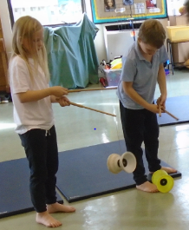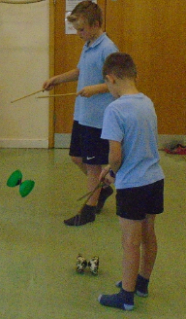

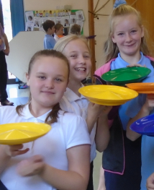

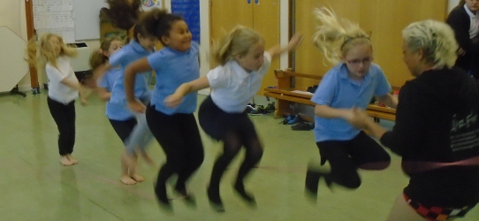

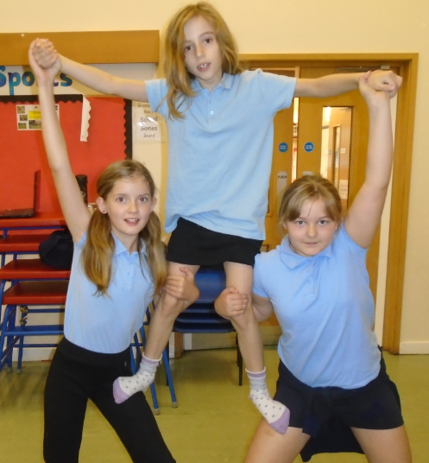

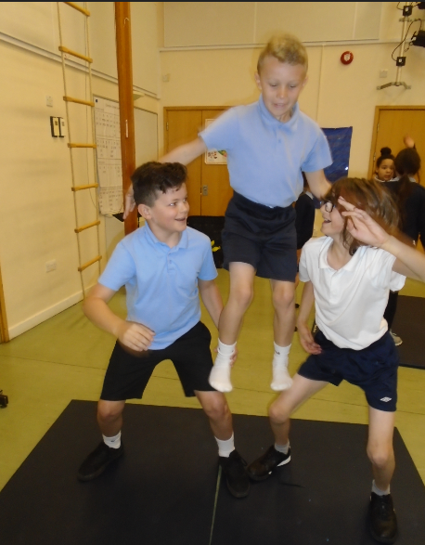

**Harvest**

We hope you enjoyed our Harvest celebration this morning. Thank you for coming along and sharing this with us.

**Ice cream tubs**

Will you be enjoying ice cream over the half term? If you have any empty 2 litres ice cream containers, please could you save them and bring them in for us to use.

Thank you!