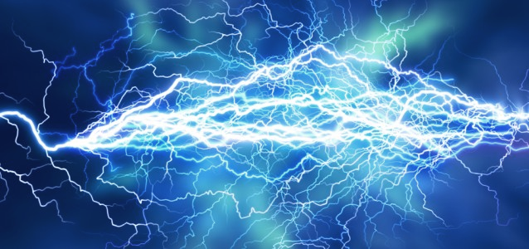
Homework Grid-It’s Electric!

LONGSHIPS CLASS
In LONGSHIPS CLASS we are going to be looking at whether electricity is really that powerful. During the term, we will be exploring circuits, light and dark and even electricity around the world. In order to begin our electrifying mission, your challenge is to choose one (or more) of the tasks below to complete during the Easter holiday. For evidence, you could bring in something as simple as a few photographs or a brief video, or you could be adventurous and create a model or a full folder of your work. High Expectations!
MATHS  How many electrical appliances do you have in your home? Which ones do you have? Which ones are used the most? Record your evidence in a table. | ENGLISH  Imagine you have suddenly gone back in time, before electricity had been created. Write or record a diary entry about your day with no electricity – you could think about what you would do for entertainment, how you would cook food to eat and how you would communicate with others. | SCIENCE/ART  Retell and record your favourite story using shadow puppets. What you will need:  -a white background  -a torch (best to do this ion a darker room)  -someone to hold the torch and camera  -any props that can help tell the story  -Camera (take photos or video the performance) | SCIENCE  Apart from electric generators, how else do we produce power in the UK? Choose one of these ways and research how it produces electricity. Do you think this is good way to create power? Explain why/why not. Prepare and present your findings as a report.
DESIGN TECHNOLOGY  Design a robot which runs purely on solar power (think ‘WALL-E’). Label all components and explain in detail what your robots functions are. | SCIENCE  How does your body use electricity? Research and present findings using one or more of the following: diagrams, table of information, fact file, report. | GEOGRAPHY  Where in the world uses the most electricity? Where uses the least? Compare and discuss why this might be. Research and present findings as a PowerPoint. | HISTORY  Research and create a report about the history of electricity. Think about: why it started, who created it and the impact it has had on us today (how do we use it/what would it be like if there was no electricity?)
ENGLISH  Prepare a poem to perform which describes electricity. Use metaphor/simile/  Personification. | DESIGN TECHNOLOGY  Design an electricity-themed board game. Label all parts and create rules. | ART  Make a cartoon strip or create a poster about electrical safety that you could share to younger pupils. | OTHER  Pretend you are an Electricity Safety Inspector. Make a checklist of possible dangers in the home i.e. too many plugs in one socket is a fire risk.

Do you need to bring your homework in as a digital copy? You could email it to the school office: grampoundroad.secretary@celticcross.education

