Tater Du

Year 3 and 4

Curriculum Newsletter

Autumn 2nd Half 2019

Potions and medicines: myth or marvel?

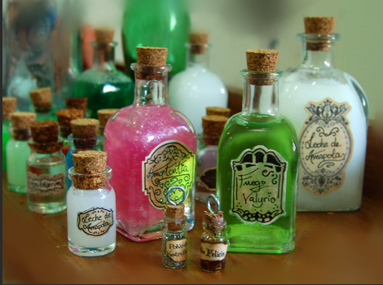

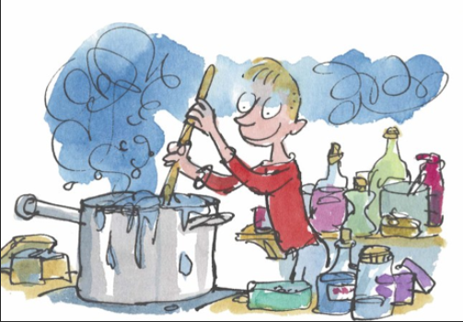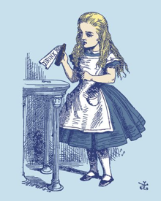

Staff:

Miss Hosking (Class Teacher)

Miss Epsly-Revill (Teaching Assistant)

Miss Parsons (Teaching Assistant in the mornings)

Mr Webb supports us with P.E. on Fridays

Mr Senior will be teaching us African Drumming on Tuesdays

Tater Du have had an incredible start to the year and are working hard in their learning both in and outside the classroom. We look forward to an interesting term ahead.

Homework and Spellings:

We will continue to follow the appropriate Spelling Shed in school. **Helping your child to learn their spellings will really make a difference!**

Please continue to record when your child reads and when they practise their times tables and spellings. You can see their previous test results on the current week’s homework sheet.

**Homework will be set on a Wednesday and should be completed by the following Tuesday. Spelling Tests will be completed on TUESDAY. Books MUST be returned to school on TUESDAY so that spelling and times table tests can be recorded on the next week’s Homework Sheet.**

Please contact me if you have any queries about the curriculum or any aspect your child’s education. I look forward to a fabulous term of learning with your child. Many thanks for your continued support.

Maths:

In Maths this half term, we will continue to focus upon Addition and Subtraction, and Multiplication and Division. In addition, the Year 4s will also learn about measuring perimeter. We will also continue to include fun investigations and games for the children to enjoy. As before, our ongoing focus is on ‘mastery’, which will include using maths in real life situations. We will be practising our times tables frequently this term, and homework will be linked to this. Please practise with your child if you get the chance, especially with the online program Times Tables Rockstars that we use in school, as this will support them in and out of school! The children have responded with great enthusiasm to our daily 3-minute TT Rockstars tests and activities, and are keen to become Rock Heroes!

English:

In English, we will be using our topic to look at a range of different texts, including Macbeth’s witches’ scene, Alice’s Adventures in Wonderland and Shakespeare’s Romeo and Juliet. We will be using Roald Dahl’s George’s Marvellous Medicine as our Guided Reading text. We will be writing poetry, fantasy stories, playscripts, newspaper reports and explanations. We will be continuing to focus on our handwriting and joining letters and consider more complex grammar and punctuation skills. Some children will continue practising their Phonics and spelling in daily Intervention groups. We will be reading Lewis Carroll’s Alice’s Adventures in Wonderland and Roald Dahl’s The Witches at the end of each day.

Science:

In Science, we will be studying Scientists and States of Matter, including solids, liquids and gases, heating and cooling and evaporation.

Computing:

In computing, we will be continuing to practise our word processing skills. The children will regularly use the iPads and complete Maths and Literacy programmes.

Religious Education:

Our topic is “Why is Truro Cathedral so important?” We are planning to visit Truro Cathedral this half term as part of our studies.

Trips

We are planning a visit to Truro Cathedral as part of our RE topic, a visit to the Eden Project to take part in a “Packaging Patrol” workshop, and are inviting some health care professionals into school as part of our learning about First Aid.

Topic (including History and Geography)

We will be looking at the use of potions and medicines throughout history, including Medieval disease and the Great Plague. We will consider the work of Marie Curie, Alexander Fleming and Edward Jenner and their contributions towards modern medicine, and study the topics of First Aid, Bacteria, Pills, Hospitals and Medicinal Plants.

Art, Design and Technology:

In DT, we will be finishing off our African masks from last half term and creating “Edible Gardens” using herbs. We will also be looking at work by Damien Hirst and Peta Clancy to develop our pointillism techniques.

Music:

In Music this half term, we will be continuing with our African Drumming lessons and look forward to inviting you to our final performance on Tuesday 19th November! Some children will be performing on Sunday 17th November in Truro Cathedral as part of the “Songs for Earth” Service, and of course, we will be practising for Christmas!

P.E.

P.E. this half term will take place on Wednesday and Friday afternoons. We will also be benefitting from coaching by the Pirates Rugby Club each week. **Please bring tracksuit bottoms and a spare pair of socks – we will be going outside WHATEVER the weather!**

This list is a brief summary of what we will be covering in the 2nd half of the Autumn Term. It may change or include other areas. Please feel free to ask the class staff any questions you might have about the content of the curriculum or any other part of school life.

**To support your child please ensure:**

* **Your child has their P.E. kit in school.**
* **All belongings are clearly named.**
* **Homework and reading is completed.**
* **Reading books and records are available in the school every day.**
* **Your child has a coat.**
* **Your child has a named water bottle in school.**

Please encourage your child to be responsible for their own belongings.