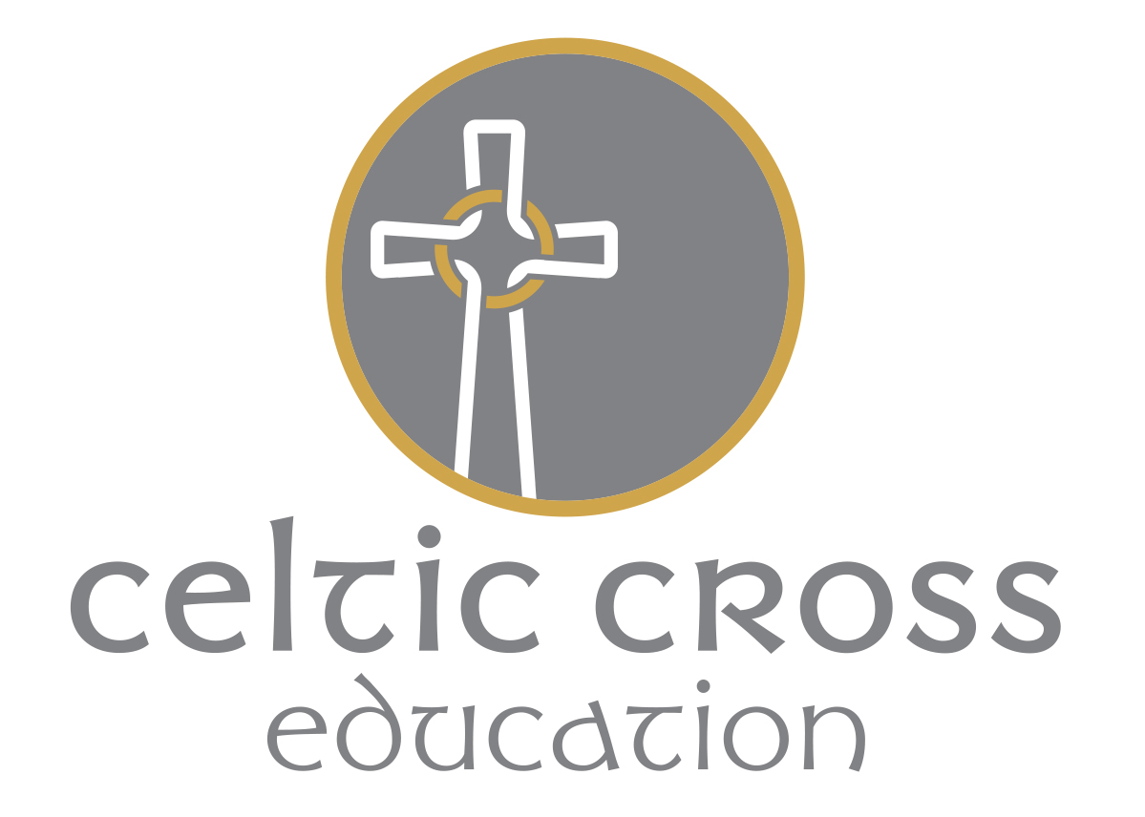

Business Card Policy
September 2020

This policy was ratified by the resources committee on Friday 2nd October.
Note that the policy was approved virtually, and signed electronically, due to the circumstances of Covid 19.
The policy will be reviewed in: September 2022
Signed: Date:
Mr P. Wootton, Chair of the Board of Directors

Designated Teacher (DT) policy for Looked-after Children (LAC) and Previously Looked-after Children (PLAC).
October 2020

This policy was ratified by the Full Board in October 2020.
Note that the policy has been signed electronically, due to the circumstances of Covid 19.
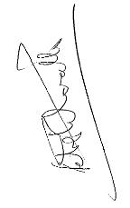
The policy will be reviewed in: October 2021.
Signed: Date: 5-10-20

Mr P. Wootton, Chair of the Board of Directors
Designated Teacher (DT) Policy for Looked-after Children (LAC) and Previously Looked-after Children (PLAC).
October 2020

Aims of the Policy:
CCE schools will aim to ensure that:
- A suitable member of staff is appointed as the designated teacher for looked-after and previously looked-after children
- The designated teacher promotes the educational achievement of looked-after and previously looked-after children, and supports other staff members to do this too
- Staff, parents, carers and guardians are aware of the identity of the designated teacher, how to contact them and what they are responsible for

Legislation and statutory guidance:
This policy is based on the Department for Education’s statutory guidance on the designated teacher for looked-after and previously looked-after children.

Definitions:
Looked-after children (LAC) are registered pupils that are:
- In the care of a local authority, or
- Provided with accommodation by a local authority in the exercise of its social services functions, for a continuous period of more than 24 hours

Previously looked-after children (PLAC) are registered pupils that fall into either of these categories:
- They were looked after by a local authority but ceased to be as a result of any of the following:
- A child arrangements order, which includes arrangements relating to who the child lives with and when they are to live with them
- A special guardianship order
- An adoption order
They appear to have:
- Been in state care in a place outside of England and Wales because they would not have otherwise been cared for adequately, and
- Ceased to be in that state care as a result of being adopted
The above information is sought from parents/carers on completion the school admissions form (and the in- year admissions form for new starters). Parent/carers are asked to provide the school with relevant orders and injunctions which are stored securely on CPOMs or My Concern which possesses Secure Sockets Layer (SSL) of encryption.
Personal education plan (PEP) is part of a looked-after child’s care plan that is developed with the school. It forms a record of what needs to happen and who will make it happen to ensure the child reaches their full potential.
Virtual school head (VSH) is a local authority officer responsible for promoting the educational achievement of their authority’s looked-after children, working across schools to monitor and support these pupils as if they were in a single school. The VSH is also responsible for providing information and advice to schools, parents and guardians in respect of previously looked-after children.

Cornwall Virtual School Team Structure 2020

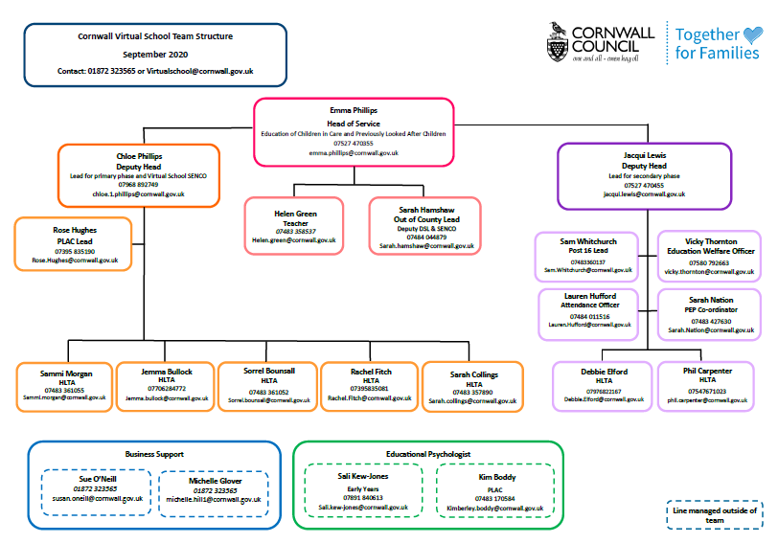

Designated Teacher arrangements at our school:
Our designated teacher is: Sarah Kennedy
You can contact her on: grampoundroad.head@celticcross.education
Our designated teacher takes lead responsibility for promoting the educational achievement of looked-after and previously looked-after children at our school. They are your initial point of contact for any of the matters set out in the section below.

Role of the Designated Teacher; Leadership Responsibilities:
The designated teacher will:
- Act as a central point of initial contact within the school for any matters involving looked-after and previously looked-after children
- Promote the educational achievement of every looked-after and previously looked-after child on roll by:
- Working with VSHs
- Promote a whole school culture where the needs of these pupils matter and are prioritised
- Take lead responsibility for ensuring school staff understand:
  - The things which can affect how looked-after and previously looked-after children learn and achieve
  - How the whole school supports the educational achievement of these pupils
- Contribute to the development and review of whole school policies to ensure they consider the needs of looked-after and previously looked-after children
- Promote a culture in which looked-after and previously looked-after children are encouraged and supported to engage with their education and other school activities
- Act as a source of advice for teachers about working with looked-after and previously looked-after children
- Work directly with looked-after and previously looked-after children and their carers, parents and guardians to promote good home-school links, support progress and encourage high aspirations
- Have lead responsibility for the development and implementation of looked-after children’s PEPs
- Work closely with the school’s designated safeguarding team to ensure that any safeguarding concerns regarding looked-after and previously looked-after children are quickly and effectively responded to
- Involve parents and guardians of previously looked-after children in decisions affecting their child’s education

Supporting looked-after children:
The designated teacher will:
- Make sure looked-after children’s PEPs meet their needs by working closely with other teachers to assess each child’s specific educational needs
- Have overall responsibility for leading the process of target-setting in PEPs
- Monitor and track how looked-after children’s attainment progresses under their PEPs
- If a child is not on track to meet their targets, be instrumental in agreeing the best way forward with them in order to make progress, and ensure that this is reflected in their PEP
- Ensure the identified actions of PEPs are put in place
- During the development and review of PEPs, help the school and relevant local authority decide what arrangements work best for pupils
A designated teacher will ensure that:
- A looked-after child’s PEP is reviewed before the statutory review of their care plan; this includes making sure the PEP is up to date and contains any new information since the last PEP review, including whether agreed provision is being delivered
- PEPs are clear about what has or has not been taken forward, noting what resources may be required to further support the child and from where these may be sourced
- The updated PEP is passed to the child’s social worker and VSH ahead of the statutory review of their care plan
- Transfer a looked-after child’s PEP to their next school or college, making sure it is up to date and that the local authority responsible for looking after them has the most recent version

Supporting both LAC & PLAC:
The designated teacher will:
- Ensure the specific needs of looked-after and previously looked-after children are understood by staff and reflected in how the school uses pupil premium funding
- Work with VSHs to agree how pupil premium funding for looked-after children can most effectively be used to improve their attainment
- Help raise the awareness of parents/carers of previously looked-after children about pupil premium funding and other support for these children
- Play a key part in decisions on how pupil premium funding is used to support previously looked-after children
- Encourage parents’ and guardians’ involvement in deciding how pupil premium funding is used to support their child, and be the main contact for queries about its use
- Ensure teachers have awareness and understanding of the specific needs of looked-after and previously looked-after children in areas like attendance, homework, behaviour and future career planning
- Be aware of the special educational needs (SEN) of looked-after and previously looked-after children, and make sure teachers also have awareness and understanding of this
- Ensure the SEND code of practice, as it relates to looked-after children, is followed
- Make sure PEPs work in harmony with any education, health and care (EHC) plans that a looked-after child may have
- Ensure that, with the help of VSHs, they have the skills to identify signs of potential SEN issues in looked-after and previously looked-after children, and know how to access further assessment and support where necessary
- Ensure that they, and other staff, can identify signs of potential mental health issues in looked-after and previously looked-after children and understand where the school can draw on specialist services
- Put in place robust arrangements to have strengths and difficulties questionnaires (SDQs) completed for looked-after children, and use the results of these SDQs to inform PEPs
- Put in place mechanisms for understanding the emotional and behavioural needs of previously looked-after children

Relationships beyond the school:
The designated teacher will:
- Proactively engage with social workers and other professionals to enable the school to respond effectively to the needs of looked-after and previously looked-after children
- Discuss with social workers how the school should engage with birth parents, and ensure the school is clear about who has parental responsibility and what information can be shared with whom
- Be open and accessible to parents and guardians of previously looked-after children and encourage them to be actively involved in their children’s education
- Proactively build relationships with local authority professionals, such as VSHs, Educational Psychologists and SEN departments
- Consider how the school works with external agencies to maximise the stability of education for looked-after children, such as:
    - Finding ways of making sure the latest information about educational progress is available to contribute to the statutory review of care plans
    - Ensuring mechanisms are in place to inform VSHs when looked-after children are absent without authorisation and work with the responsible authority to take appropriate safeguarding action
    - Talking to the child’s social worker and/or other relevant parties in the local authority regarding any decisions about changes in care placements which will disrupt the child’s education, providing advice about the likely impact and what the local authority should do to minimise disruption
    - Making sure that, if a looked-after child moves school, their new designated teacher receives any information needed to help the transition process
    - Seek advice from VSHs about meeting the needs of individual previously looked-after children, but only with the agreement of their parents or guardians
Make sure that for each looked-after child:
    - There’s an agreed process for how the school works in partnership with the child’s carer and other professionals, such as their social worker, in order to review and develop educational progress
    - School policies are communicated to their carer and social worker and, where appropriate, birth parent
    - Teachers know the most appropriate person to contact where necessary, such as who has the authority to sign permission slips
Where a looked-after child is at risk of exclusion:
    - Contact the VSH as soon as possible so they can help the school decide how to support the child to improve their behaviour and avoid exclusion becoming necessary
    - Working with the VSH and child’s carers, consider what additional assessment and support needs to be put in place to address the causes of the child’s behaviour
    - Where a previously looked-after child is at risk of exclusion, talk to the child’s parents or guardians before seeking advice from the VSH on avoiding exclusion

Monitoring arrangements
This policy will be reviewed annually by Tamsin Parry. At every review, it will be approved by the Trust Board.

