Homework and Spellings:

Homework will be set weekly and spelling checks will be given on Wednesday. Please continue to hear your child read every night and record it in their reading record. We completely understand this can be time consuming but reading a few pages a night really helps their progress.

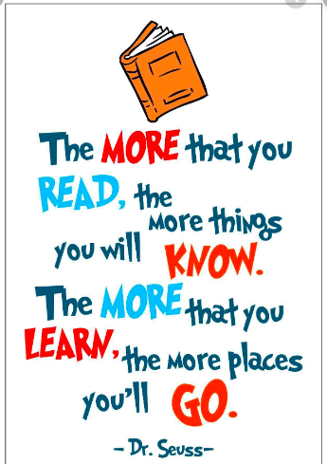

Pendeen and Trevose

Curriculum Newsletter

Autumn 2nd Half 2019

Do you remember when…?

Year 1 and Year 2

. 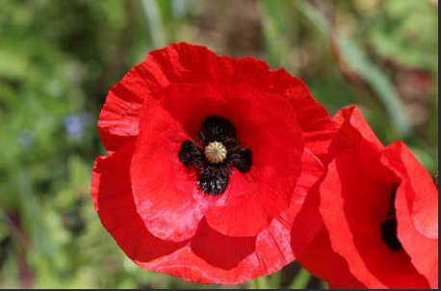

Please find enclosed information regarding the learning taking place this half term in Year One and Year Two. If you have any queries about the curriculum or any aspect of your child’s education, please speak to your child’s class teacher.

Thank you for your continued support.

Mrs Jones and Miss Kennedy

Maths: Year 1-Within the Part whole unit the children will write number sentences and make number bonds to 10. We will then move onto addition and subtraction within 10 and solving word problems. We will also name and describe 2D and 3D shapes and make patterns. Year 2-will learn addition and subtraction, money and multiplication and division. All children have started using TT Rockstars.

English: Some children will continue to do daily phonics and writing in Read Write Inc and Get writing. Once this programme is complete they will be taught Literacy using the Talk For Writing technique. We will also be doing cross curriculum writing. The children will be introduced to SPAG sessions (spelling, punctuation and grammar) and we will continue focusing on handwriting. All children will have guided reading sessions and reading for pleasure or Accelerated Reading sessions.

Science: The children will observe the changes across the four seasons. They will observe and describe weather associated with the seasons and how day length varies. The children will work scientifically to gather and record data making tables and charts about the weather.

Art: The Colour Chaos unit will teach the children about choosing, using and mixing their own colours to create art work that shows progression in skills. The children will have the opportunity to explore the life and work of key abstract artists and, working primarily in paint, create pieces in a range of abstract styles.

History

In History we will learn about changes in living memory with reference to technology, World War 2 and The Berlin Wall. We will invite grandparents into school to share memories and to help the children understand how technology has evolved over the last few decades.

Religious Education: we will be focusing on what it is like to be a Christian in Grampound Road. We will visit a local church. We will follow how Jesus changed people’s lives and continues to do so.

In preparation for our nativity in December we will also focus on the nativity story.

Music: This half term we will continue to focus on the song : Hey You! - a Hip Hop song for children. We will also be learning lots of songs for our school nativity.

Computing: we will be using the Ipads and apps to help us to learn and using a variety of software to accomplish set goals.

P.E. will take place on Monday and Friday. We will be learning Dance and Invasion Games.

PSHE:

All children will have weekly sessions to support their emotional well being and we are following the Seal programme of study alongside TIS activities.

To support your child please ensure:

* Your child has their P.E. kit in school.
* All belongings are clearly named.
* Book bags are brought into school daily.
* Your child has a coat with a hood in school.
* Homework books and reading record books are available in the book bags.
* Please encourage your child to be responsible for their own belongings.
* Homework and reading is completed.

.