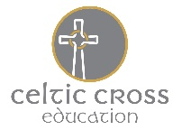
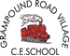
Tater Du’s Easter Home Learning Activities
Our topic this coming term will be Traders and Raiders

Research  Use information books and online sources to help you answer the following enquiry questions:  • Who were the Anglo-Saxons and Vikings?  • Why did they come to Britain?  • What was the Anglo-Saxon period in Britain?  • What was the Viking Age in Britain? | Nutrients  For science topic, we will be looking at animals (including humans)  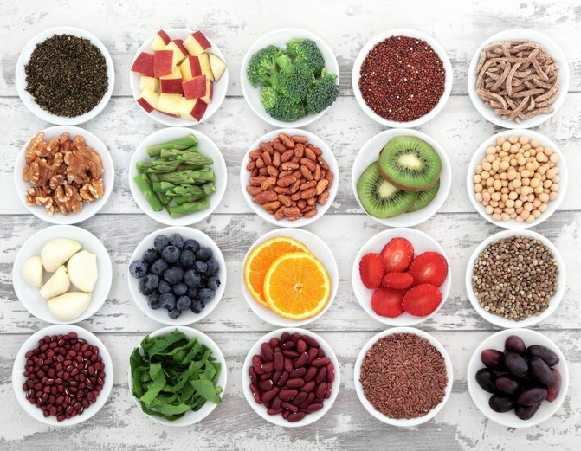  Both animals and humans need to eat healthy food in order to grow and develop.  See what you can find out about the word nutrient what different types there are and what foods you find them in. | Viking poetry!  Can you make a volcano acrostic poem? You use the letters for the word Viking to write something about the topic.  Here’s an example (a poem about the sun)  Sunburn is bad for your skin.  Use sunscreen on bright days.  Never stay in the sun too long.
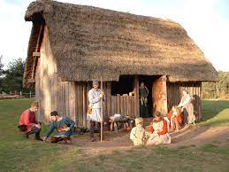  Way of life  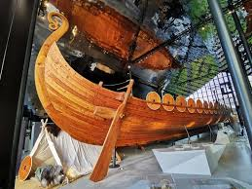  Use a range of sources to find out about the Anglo-Saxon and Viking way of life. Record your findings under headings of your choice on two mind maps – one for the Anglo-Saxons and one for the Vikings. Example headings could include food, homes, art, beliefs, law and warfare. Use mind maps to help you write two reports: ‘The Anglo-Saxon way of life’ and ‘The Viking way of life’. Include the title, an opening paragraph, headings, detailed facts and pictures with captions on each report. | 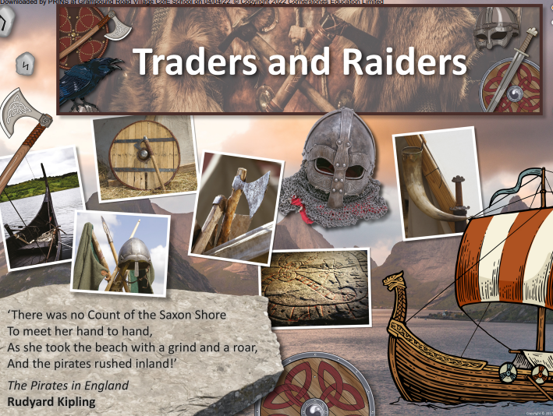 | Skeletons  We will be looking at skeletons for our science topic this term. Can you draw and label a human skeleton?  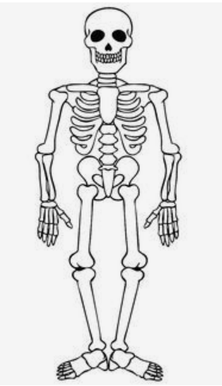
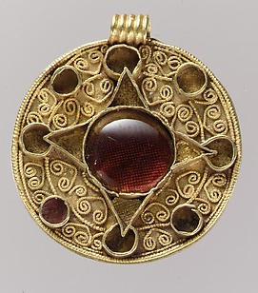  Artefacts  Search the online collections on the British Museum and the Metropolitan Museum of Art websites to view artefacts that were made and belonged to the Anglo-Saxon and Viking people using key search terms. Choose two artefacts that interest you. Record your observations and findings.  (metmuseum.org or britishmuseum.org) | Art  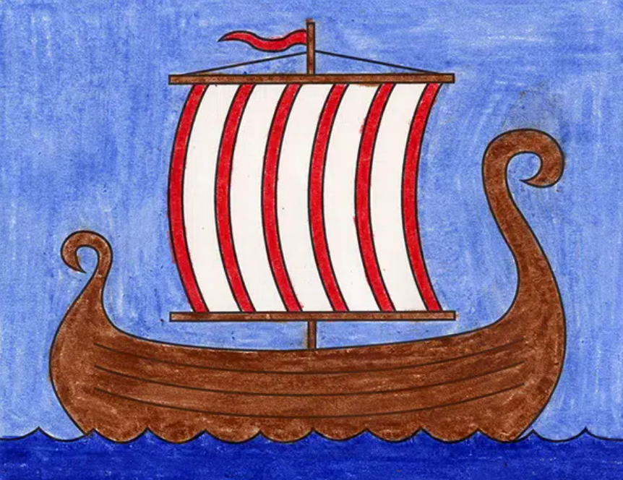  Use whatever resources you have to draw/paint/create a Viking longship! | Useful websites:  Historical Association – Anglo-Saxons: a brief history Britannica Kids – Anglo-Saxons  JORVIK Viking Centre – The Vikings  The British Library – Anglo-Saxon Chronicle  V&A – Illuminated Manuscripts  Britannica Kids – Sutton Hoo  JORVIK Viking Centre – Coppergate Dig  DKfindout! – Alfred The Great Facts For Kids  Britannica Kids – King Arthur

