Tater Du

Year 3 and 4

Curriculum Newsletter

Spring 1st Half 2020

The Rampaging Romans?

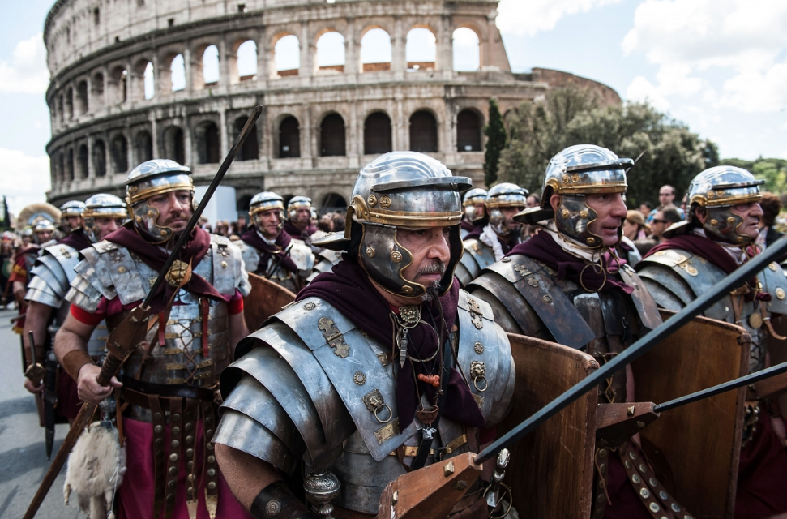

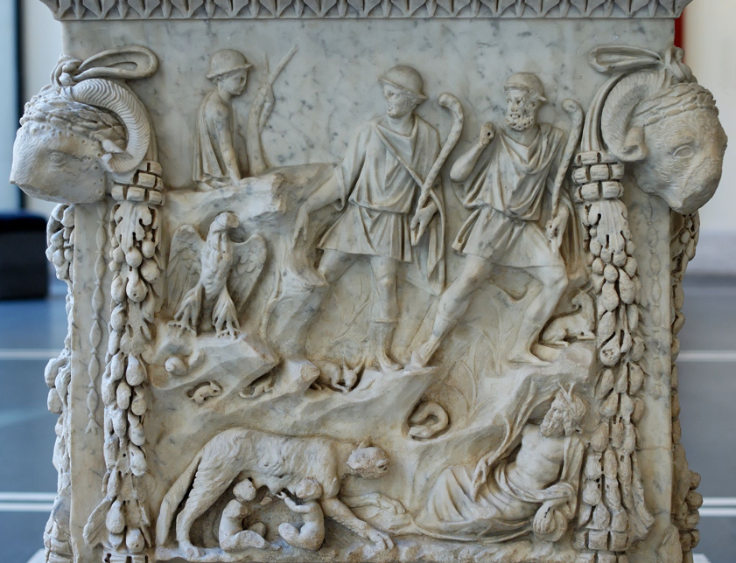 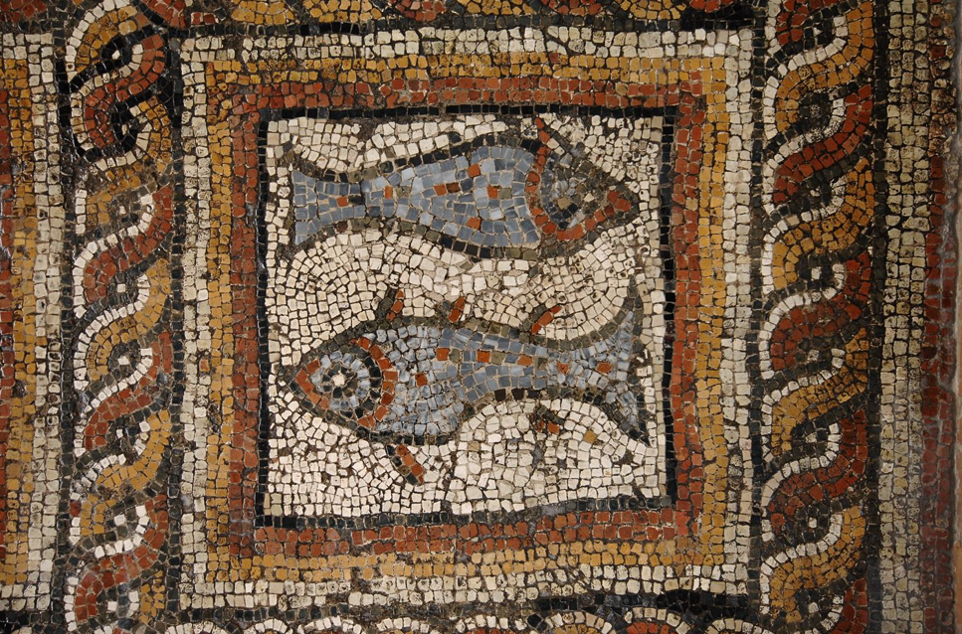

Staff:

Miss Hosking (Class Teacher)

Miss Epsly-Revill (Teaching Assistant)

Mrs Warne (Teaching Assistant)

Miss Mills (Teaching Assistant)

Mr Webb supports us with P.E. on Fridays

We all hope that you have all had a restorative Christmas break, and we wish you a very happy and peaceful New Year! We are looking forward to a shorter but action-packed half term with a focus upon Roman History,

Homework and Spellings:

We will continue to follow the appropriate Spelling Shed in school. **Helping your child to learn their spellings will really make a difference!**

Please continue to record when your child reads and when they practise their times tables and spellings. You can see their previous test results on the current week’s homework sheet.

**Homework will be set on a Wednesday and should be completed by the following Tuesday. Spelling Tests will be completed on TUESDAY. Books MUST be returned to school on TUESDAY so that spelling and times table tests can be recorded on the next week’s Homework Sheet.**

Please contact me if you have any queries about the curriculum or any aspect your child’s education. I look forward to a marvellous term of learning with your child. Many thanks for your continued support.

Religious Education:

Our topic is “What kind of world did Jesus want?” We will be considering the links between the calling of the first disciples and how Christians today try to follow Jesus and be ‘fishers of people’.

Topic (including History and Geography)

In Geography, we will be looking at where Italy and in particular Rome is, what it is like to holiday there and how it compares to England. In History, we will be learning about the founding of Rome. what Roman society and life were like, who the gladiators, gods and goddesses were, and what the Romans did for us in Great Britain.

Art, Design and Technology:

We will be looking at Roman mythology and Roman mosaics.

Music:

In Music this half term, we will be using the Charanga resources to practise our singing and composing skills around Bob Marley’s song Three Little Birds.

P.E.

P.E. this half term will take place on Wednesday and Friday afternoons. We will be learning about outdoor education, including orienteering around our school grounds, and we will also be improving our gymnastics skills.

Trips

We are planning a visit to Truro Museum as part of our learning about the Romans.

This list is a brief summary of what we will be covering in the 1st half of the Spring Term. It may change or include other areas. Please feel free to ask the class staff any questions you might have about the content of the curriculum or any other part of school life.

**To support your child please ensure:**

* **Your child has their P.E. kit in school.**
* **All belongings are clearly named.**
* **Homework and reading is completed.**
* **Reading books and records are available in the school every day.**
* **Your child has a coat.**
* **Your child has a named water bottle in school.**

Please encourage your child to be responsible for their own belongings.

Maths:

In Maths this half term, we will continue to focus upon Multiplication and Division. In addition, the Year 4s will also learn about measuring area and the Year 3s will be learning about statistics. We will also begin to learn about fractions. As before, our ongoing focus is on ‘mastery’, which will include using maths in real life situations. We will be practising our times tables frequently this term, and homework will be linked to this. Please practise with your child if you get the chance, especially with the online program Times Tables Rockstars that we use in school, as this will support them in and out of school! The children are very competitive during our daily 3-minute TT Rockstars tests and activities, and are keen to become Rock Heroes! Please be mindful that the Year 4s will be taking a Multiplication Tables Check Assessment in June and will need to answer 25 questions with a time limit of 6 seconds per question. The questions are all multiplication and will be from all the tables up to 12 x 12, but there will be a particular focus upon the 6, 7, 8, 9, and 12 x tables. Please assist your child in learning their times tables as this will really help.

English:

In English, we will be looking at Roman Myths and Legends and will be working towards writing our own versions. We will also be looking at writing explanations and will continue to use the Talk for Writing approach. We will complete Roald Dahl’s George’s Marvellous Medicine in our Guided Reading session and will also complete the last few chapters of Alice’s Adventures in Wonderland before commencing The Lion, the Witch and the Wardrobe as our class reader at the end of the day. As usual, we continue to focus on our handwriting and joining letters and consider more complex grammar and punctuation skills. Some children will continue practising their Phonics and spelling in daily Intervention groups.

Science:

In Science, we will be studying forces, friction and magnetic attraction. They will learn about forces in the context of pushing and pulling, and will identify different actions as pushes or pulls. They will identify magnetic materials and will conduct an investigation into the strength of different types of magnet. The children will also have a chance to explore the way magnetic poles can attract and repel.

Computing:

In computing, we will be continuing to practise our word processing skills. The children will regularly use the iPads and complete Maths and Literacy programmes.