MAT Attendance policy

July 2018

Rationale
All school staff are committed to working with parents and pupils as this is the best way to guarantee as high a level of attendance as possible. Through good attendance, we ensure every child’s welfare and life opportunities are promoted to the best of their ability.

Introduction
“Missing education leaves children vulnerable to falling behind. Regular school attendance plays a key role in effective safeguarding. All schools must have robust procedures in place for pupil admission, ongoing attendance and punctuality.” (Achieving High Attendance 2016, Cornwall Council).

At Celtic Cross Education, we aim for an environment which enables and encourages all members of the community to strive for excellence. For our children to gain the greatest benefit from their education, it is vital that they attend school regularly and your child should be at school, on time every day, unless the reason for the absence is unavoidable.

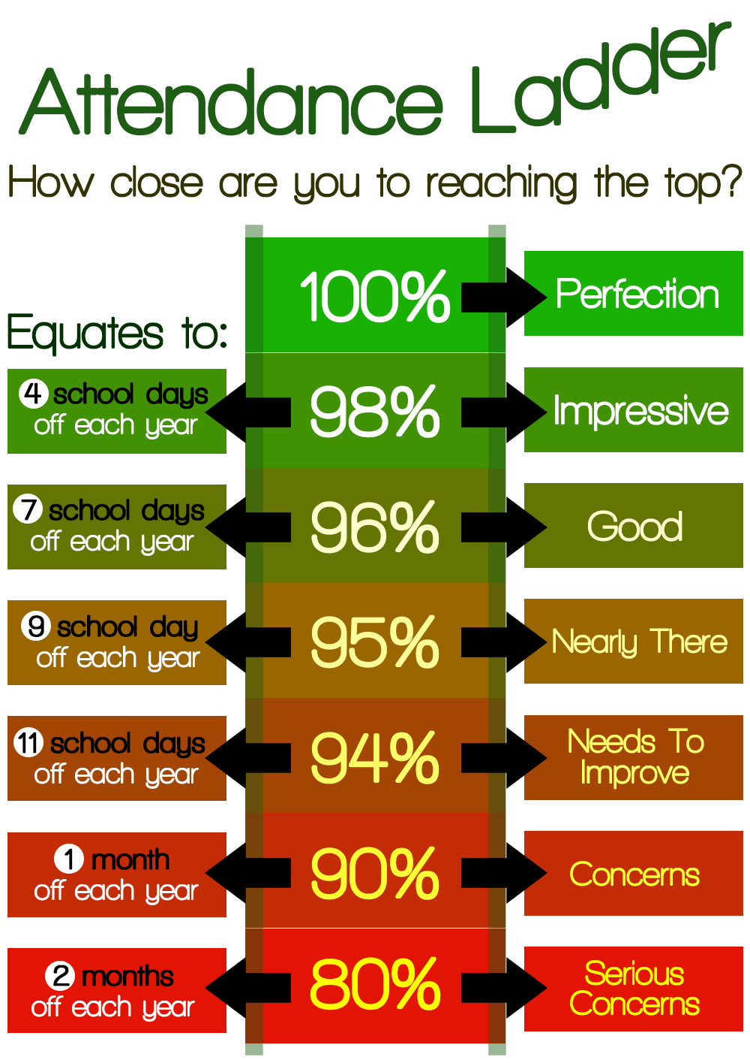
It is very important, therefore, that parents ensure their child attends regularly and punctually, this policy sets out how, together, we will achieve this.

Why regular attendance is important?
Learning
Any absence affects the pattern of a child’s schooling and regular absence will seriously affect their learning. Any pupil’s absence disrupts teaching routines, and so, may affect the learning of others in the same class.

Ensuring your child’s regular attendance at school is your legal responsibility and permitting absence from school without a good reason creates an offence in law and may result in prosecution.

Safeguarding
Your child may be at risk of harm if they do not attend school regularly. Safeguarding the interests of each child is everyone’s responsibility and within the context of this school, we will adhere to ‘Working together to Safeguard Children’ (March 2015):
-Protecting children from maltreatment.
-Preventing impairment of children’s health or development.
-Ensuring that children are growing up in circumstances consistent with the provision of safe and effective care.
-Taking action to enable all children have the best life chances.
Failing to attend School on a regular basis will be considered as a safeguarding matter.

Promoting Regular Attendance
Helping to create a pattern of regular attendance is everybody’s responsibility - parents, pupils and all members of school staff.

To help us all to focus on this we will:
- Give you details on attendance in our weekly newsletter;
- Track every child’s attendance and notify you half-termly if your child’s attendance is below 96%;
- Notify you if your child/children have had 10 or more late arrivals per term and we may inform the Education Welfare Officer.
- Celebrate good attendance using incentives; both for individuals and classes with exceptional attendance
- Reward good or improving attendance through class competitions, certificates and incentives

The Law relating to attendance
Section 7 of the Education Act 1996 states that ‘the parent of every child of compulsory school age shall cause him / her to receive efficient full-time education suitable:-
(a) to age, ability and aptitude and
(b) to any special educational needs, he/ she may have
Either by regular attendance at school or otherwise’

The Law relating to safeguarding
Section 175 of the Education Act 2002 places a duty on local authorities and governing bodies to have regard to guidance issued by the Secretary of State with regard to safeguarding and promoting the welfare of children and pupils under the age of 18.

Understanding types of absence
Every half-day absence from school has to be classified by the school (not by the parents), as either AUTHORISED or UNAUTHORISED. This is why information about the cause of any absence is always required, preferably in writing.

Authorised absences are mornings or afternoons away from school for a good reason like illness, medical/dental appointments which, unavoidably, fall in school time, emergencies or other unavoidable causes.

Unauthorised absences are those which the school does not consider reasonable and for which no ‘leave’ has been given. This type of absence can lead to the Local Authority using sanctions and/or legal proceedings. This includes:

- Parents/carers keeping children off school unnecessarily
- Truancy before or during the school day
- Absences which have never been properly explained
- Children who arrive at school too late to get a mark
- Shopping, looking after other children or birthdays
- Day trips and holidays in term time which have not been agreed

Whilst any child may be off school because they are ill, sometimes they can be reluctant to attend school. Any problems with regular attendance are best sorted out between the school, the parents and the child. If your child is reluctant to attend, it is never better to cover up their absence or to give in to pressure to excuse them from attending. This gives the impression that attendance does not matter and usually make things worse.

Any student in Celtic Cross Education identified as having attendance below 96% will have a letter sent to their parents. If this does not improve and drops below 91%:

96% to 93% - Level 1 letter to be sent
93% to 90% - Level 2 letter to be sent
Less than 90% - Level 3 to be sent

However, should parent(s) provide evidence from a medical practitioner advising that the period of absence was necessary, the absence for the evidenced period will be authorised.

The following national codes will be used to record attendance information.
CODE | DESCRIPTION | MEANING
/ | Present (AM) | Present
\ | Present (PM) | Present
B | Educated off site (NOT Dual registration) | Approved Education Activity
C | Other Authorised Circumstances (not covered by another appropriate code/description) | Authorised absence
D | Dual registration (i.e. pupil attending other establishment) | Approved Education Activity
E | Excluded (no alternative provision made) | Authorised absence
F | Extended family holiday (agreed) | Authorised absence
G | Family holiday (NOT agreed or days in excess of agreement) | Unauthorised absence
H | Family holiday (agreed) | Authorised absence
I | Illness (NOT medical or dental etc. appointments) | Authorised absence
J | Interview | Approved Education Activity
L | Late (before registers closed) | Present
M | Medical/Dental appointments | Authorised absence
N | No reason yet provided for absence | Unauthorised absence
O | Unauthorised absence (not covered by any other code/description) | Unauthorised absence
P | Approved sporting activity | Approved Education Activity
R | Religious observance | Authorised absence
S | Study leave | Authorised absence
T | Traveller absence | Authorised absence
U | Late (after registers closed) | Unauthorised absence
V | Educational visit or trip | Approved Education Activity
W | Work experience | Approved Education Activity
X | Untimetabled sessions for non-compulsory school-age pupils | Not counted in possible attendances
Y | Unable to attend due to exceptional circumstances | Not counted in possible attendances
Z | Pupil not yet on roll | Not counted in possible attendances
# | School closed to pupils | Not counted in possible attendances

Persistent Absenteeism (PA)
A pupil becomes a ‘persistent absentee’ when they miss 10% or more of schooling across the school year for whatever reason. Absence at this level is doing considerable damage to any child’s educational prospects and we need parents’ fullest support and co-operation to tackle this.

We monitor all absence thoroughly. Any case that is seen to have reached the PA mark or is at risk of moving towards that mark is given priority and you will be informed of this immediately.

PA pupils are tracked and monitored carefully through our pastoral system and we also combine this with academic mentoring where absence affects attainment.

Absence Procedures
If your child is absent you must:
- Contact us as soon as possible on the first day of absence;
- Or, you can call into school and report to reception

If your child is absent we will:
- Telephone or text you on the first day of absence if we have not heard from you;
- Invite you in to discuss the situation with our Attendance Officer and/or a member of the senior management team if absences persist;
- Refer the matter to our Education Welfare Officer if attendance moves below 90% over a rolling year or if a decision is made by the Senior Leaders.
- At our discretion, make home visits to check on the child’s welfare if we have not been informed of the reason for their absence.
- We are legally obliged to refer a child as missing education if we believe that to be the case.

Telephone numbers
There are times when we need to contact parents about lots of things, including absence. We need to have your contact numbers at all times. To help us to help you and your child we ask that we are provided with an up to date number.
You have a duty to notify school as soon as possible of any changes to contact details.

Informing Schools
Parents are expected to contact school at an early stage and to work with the staff in resolving any problems together. If difficulties cannot be sorted out in this way, the school may refer the child to the Education Welfare Officer (EWO) from the Local Authority.

Education Welfare Service
If your child’s attendance falls below 90% over a rolling year, the Education Welfare Officer (EWO) will ask us directly for information relating to your child’s absences. As we are held to account for such cases, we work closely with the service, acting on their advice. In some instances, it may be necessary for the officer to meet with you and/or your child to discuss the reason for absence, so please advise us if you would prefer contact before such action. Please be aware if your child’s absences persist, an EWO can use sanctions such as a Penalty Notice fine or prosecutions in the Magistrates Court to address irregular school attendance.

Lateness
Poor punctuality is not acceptable. If your child misses the start of the day they can miss vital information and could regularly miss the same lesson. Late arriving pupils also disrupt lessons and this can be embarrassing for the child.

How we manage lateness?
The register will be closed 30 minutes after the school’s start time. This means that children arriving after this time will receive a mark that shows them to be on site, but this will not count as a present mark and it will mean they have an unauthorised absence. You could, therefore, face the possibility of a Penalty Notice if the problem persists.

If your child has a persistent late record you will be asked to meet with a member of school staff and/or Education Welfare Officer to resolve the problem, but you can approach us at any time if you are having problems getting your child to school on time.

Leave of Absence in Term Time
Taking holidays in term time will affect your child’s schooling as much as any other absence and we expect parents to help us by not taking children away in term time. Remember that any savings you think you may make by taking a holiday in school time are offset by the cost to your child’s education.

There is no automatic entitlement in law to time off in school time to go on holiday and the government made an amendment to the Education (Pupil Registration) (England) Regulations 2006 in September 2013 to reflect this.

Leave of absence shall not be granted unless –
- an application has been made in advance to the proprietor by a parent with whom the pupil normally resides: and
- the proprietor, or a person authorised by the proprietor in accordance with paragraph (1), considers that leave of absence should be granted due to the exceptional circumstances relating to that application.

All applications must be made in writing to the Head of School at least 20 school days prior to the requested leave date. Where the decision is made not to authorise leave in term time, school will inform parent/carers in writing. Please do not book a holiday before being given permission for absence from the school.

A general guide for parents is, leave for any holiday, activity or event that could be arranged during the annual 13 week holiday time would not be authorised.

On any occasion that school refuses a request for leave in term time, should a parent/carers proceed with the leave it will be recorded as a (G) (family holiday not agreed or in excess of agreement), on schools register.

Failure to notify and/or request leave of absence in term time, providing at least 5 day notice will result in all absence being recorded as (O) (unauthorised absence not covered by any other description).

Penalty Notices
Whilst we would hope that the supportive strategies outlined above would be successful in improving attendance and punctuality, Celtic Cross Education would consider using Penalty Notices if they felt it appropriate in collaboration with the EWO.
Penalty Notices can be requested for unauthorised absence or unauthorised holiday during term time. The absence/holiday must be 10 half-day sessions or more (i.e. the equivalent of 5 school days). The Penalty Notice Officer will consider requests when attendance is or would fall to below 94.5%. When requesting that a Penalty Notice be issued, the school must hold that attendance is not “regular” (i.e. in accordance with this policy).
A holiday refusal letter informs parents/carers that the leave will be unauthorised and, as such, if they take the leave they may be liable under section 444A and section 444B of the Education Act 1996 and could be issued with a Penalty Notice of £60 per child, per parent if paid within 21 days, increasing to £120 if paid within a further 7 days (total of 28 days). Non-payment may result in prosecution. If the 28-day deadline passes without payment from the parent/carer, the Penalty Notice Officer informs the referrer and requests that they prepare the necessary paperwork for prosecution.
When considering issuing a penalty notice, the Cornwall Council document, “Penalty Notices- A Guide for Education Welfare Officers and Schools.” (October 2017) which includes the following flowchart:
Unauthorised holiday
Of 10 or more sessions in any 10 weeks period (school must have refused request in writing and issue warning)
Unauthorised absence
Of a minimum of 5 session in any 5 week period. This can include U coded absence.
There is no limit to the number of formal warnings a parent can be sent but a maximum of 2 Penalty Notices can be issued per parent, per child in a 12 month period.
Request for Penalty Notice
Completed, signed by the Lead Professional (within 15 days of return to school for unauthorised holidays) to LA EWO service
Request agreed
By Penalty Notice Officer/Senior EWO
Penalty Notice Issued
The Notice is deemed to ne received by the parent 2 working days after sending 1st class post

Penalty Notice received Day 1
£60 due up to 21 days Day 21
£120 due between Days 21 and 28 Day 21-28
LA send letter that payment
not received Day 28

If not paid before Day 28, the case of irregular attendance at school will be prosecuted in the magistrate’s court.
Within 25 day period 5 or more additional unauthorised absences are recorded
No further action
No further UAs or insufficient UAs to reach Penalty Notice threshold
School sends warning letter to parents advertising that a Penalty Notice may be issued if there are further unauthorised absence (UAs) in the next 25 days which bring the total of UAs to 10 or more within this 10 week period OR the LA First Warning can be used if the school uses the EWO?
School targets, projects and special initiatives
The school has targets to improve attendance and your child has an important part to play in meeting these targets. Targets for the school and for classes are displayed and shared with pupils in school and communicated to parents weekly via the school newsletter.

The minimum level of attendance for this school is 96% and we will keep you updated regularly about progress to this level and how your child’s attendance compares.
Our target is to achieve better than this because we know that good attendance is the key to children fulfilling their potential.

Those people responsible for attendance matters in this school are:

Head of School:

Senior Leaders:

Attendance Officer: (delete if appropriate)

