PE Funding Grampound Road Primary School Impact Statement Sep 2015 – Summer 1 2016 £8515 based on 103 pupils
What do we want to do? | How will we do it? | Impact? | Cost | Sustainability
To develop and enhance our sporting partnerships with local  schools and to have extensive  CPD opportunities. | Roseland Cluster Group Network  Andy Ayres-sport coach  2 x terms support  2 hrs a week  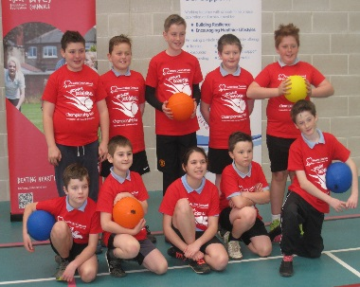 | Extensive CPD opportunities for subject leader and all staff members – class teachers and TA’s. Staff feeling more confident delivering PE and feel well supported by coach. They have developed knowledge of Dodgeball, hockey and gym skills.  Sporting challenges set by Roseland and sports expert Andy Ayres which encourage children to take part in competitive sports challenges on a regular basis. Winners of the sports challenge are presented with a certificate within celebration assemblies and this therefore celebrates sporting successes. Dodgeball out of 147 schools we finished in 12th place. Participation in Roseland events has shown an improvement in pupil’s skills and progress in PE. | £3600 | The Subject Leader shares expertise with teaching staff and this has a positive impact on the teaching and learning of Physical Education within our school.  All children are able to partake in intra-school competitive sports challenges, set by the Roseland secondary school, therefore developing their engagement in competitive sports.
To have extensive CPD opportunities and upskilling of all staff. | The Cornish Cricket Company Autumn Term 15 Sport Coaches | Through pupil conferencing and observation of PE the coordinator has identified improved engagement and enthusiasm by the majority of pupils.  Through assessment and monitoring of the progression of skills pupils are achieving age expected levels and achieving many PE skills.  Uptake of sport activities has increased significantly – Dance, cross country, multi skills, dodgeball, hockey, football, Roseland sports festivals.  Teachers/staff confidence increased by being up skilled. Now able to transfer these into their teaching and leading of sports as extra-curricular. | £1444 | This extensive CPD means staff are upskilled and confident to teach sports.  Staff embed lifelong learning and understanding of the importance of physical activity.  Due to increased PE participation this means pupils fitness levels are improving.
 | The Cornish Cricket Company Spring Term 16 Sport Coaches |  | £1058
 | The Cornish Cricket Company Summer Term 16 Sport Coaches |  | £1680
What do we want to do? | How will we do it? | Impact? | Cost | Sustainability
Ensure that PE lessons are good or better across the school.  Summer 2nd Half 2016 | Subject Leader to observe lessons across the school | All children to make progress within their lessons and all teachers to be enthusiastic about the importance of Physical Education. Teachers encouraged children to talk about the importance of keeping fit and healthy and children could confidently share what was happening to their bodies as a result of them exercising. Clear progression of skills taught Staff had applied what was learnt within staff meeting and children were provided with the very best learning opportunities. | Head of School time | Children receive the very best physical education lessons.  Teachers will be provided with feedback and are continually striving to deliver the very best teaching and learning experiences for our children.
To inspire our children to partake in sports that they may not have tried before and to develop a love of learning for physical education. | Plan an Olympic sports day across our trust. 7.7.16  Introduce ‘Run a Mile’ daily 15 minutes. Summer 1st Half 2016  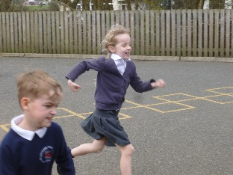  Provide private sports clubs –Dance (Hip Hop) Children to perform in concert at secondary school. | 125 children to take part in our trust Olympics Day engaging in physical activities.  Parents had commented on how they thought it was brilliant that the whole school and staff were participating in this. This is having a positive effect on their love for physical education. Teachers have noted an improved concentration during the lesson which follows as well as improving the fitness of children.  12 pupils (girls and boys) attend an additional dance class weekly and will perform in concert in June 2016. | PPA for Sports lead from BB school.  Parents pay fee. | Children secure a love of learning in physical education.  Pupils and parents have commented that they enjoyed taking part in the Run a Mile Daily. Pupils have commented that they are now aim to run further and be ‘less out of breathe’ (Yr 6 pupil)  Children thoroughly enjoy the Dance Club and says it helps them to get fit and improve coordination.
What do we want to do? | How will we do it? | Impact? | Cost | Sustainability
CPD for subject leader and class teachers | REAL PE/REAL gym training for all staff.  1.12.15 PE coordinator  5.2.16 REAL Gym NQT training CM  20.4.16 all class teachers | All class teachers have been upskilled in PE within school. The focus of the training was around best practise for teaching and learning within physical education. The impact therefore being that staff are confident with the changes to the National Curriculum and using the REAL PE programme and resources effectively. | Part of purchase of the materials. | Expertise shared with teaching staff and this has a positive impact on teaching and learning of Physical Education. Members of staff within our school are confident with using the scheme and understanding the progression of skills. REAL PE portal ongoing support.
To develop outdoor physical education experiences for our children.  Summer 2nd 2016 | Year 1 children – outdoor area/physical play  Outdoor Play Company –design to create physical experiences.  Tesco Bid Application/Volunteer Worker Scheme  Scrap store materials – create different physical activities. | Children to develop a real love for outdoor education within school.  Improve fitness and health & wellbeing of all.  Improve and develop fine and gross motor skills. | £481 | Children to be inspired to partake in physical activities. Children to enhance their love for physical activity which is imperative as we encourage our children to become physically active and reduce their ‘screen time’. We are aware of the implications for their health and fitness if they spend hours indoors and reports have linked technology to children becoming weaker and less muscular; therefore providing our children with these experiences is invaluable.
Children to partake in a range of sporting activities during their lunch times.  Summer 2nd 2016 | Employ additional lunchtime sport leader to lead sporting activities. A range of sporting activities on offer to encourage children to partake in sports that they may not have tried before / enhance their skill set for a range of sports. | Children will engage in a range of sporting activities on a daily basis. They will be encouraged to try new sports that they may never have tried before. Children who may be less active are invited to join in. | £252 | The number of sports activities will increase during lunchtimes meaning a larger participation rate of children being able to access physical activities outside of the curriculum time.

