

St Piran’s Post

September 2015 Edition

**ISSUE 1**

MC900058404[1]**‘Nurturing God’s gifts with compassion and drive, so that all our children succeed, learn and thrive.’**

**Welcome back to our schools and we hope you all had a great summer holiday!**

**We welcome our new Executive Principal, Mark Lees to the Trust.**



Mark Lees has now taken the post of Executive Principal of our five schools. We know that many of you met Mark during the summer term but he looks forward meeting more of you in September 2015. Mark aims to be in each school every week and will be able to catch up with you before and after school or by making an appointment through his admin support.

**You can contact Mark on:** [enquiries@stpiranscross.co.uk](mailto:enquiries@stpiranscross.co.uk)

Mark will work closely with the Head of each school who will manage the school on a day to day basis. When in our schools, Mark has asked staff to ensure that children who have made a special effort or made a significant achievement to come to see him for an ‘EP’ Award. He hopes to see lots of children during the first few weeks while he is learning names etc.

Mark will work hard to ensure clear communication with parents and the local communities. You, of course, will receive your weekly newsletter from your school. A monthly newsletter will be sent out from the MAT. You will have opportunities to come into our schools as well. We will be working in the coming weeks to improve the MATs website and introduce a social media connection for parents and the local community.

**Our Central Team**

You may be aware that the MATs central team is based in Roche. Our team works tirelessly to take the pressure off of our schools so that they can concentrate on teaching and learning. They can be contacted on 01726 250260

Our team is:

* **Nicola Gordon** - Business Manager
* **Kathryn Trudgeon** - Assistant Business Manager
* **Rebecca Bishop** - HR Officer
* **Natasha Trethewey** - Finance Officer
* **Victoria Cartwright** - Clerk to LGB & Board of Directors, also Mr Lees PA.

**Welcome to all of our new staff!**

We welcome several new members of staff to our schools this term and I am sure that you will quickly get to know them. Below are some of our newly qualified teachers undertaking our induction programme in July 2015.

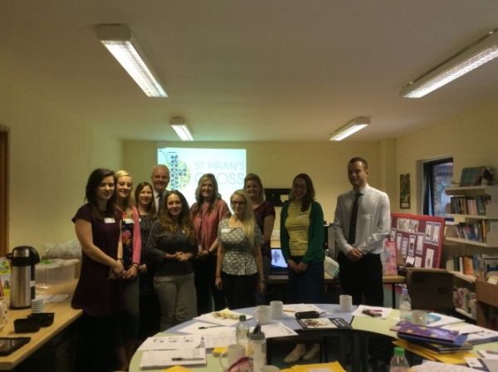

**St Piran’s Cross Multi- Academy Trust, Our Values and Vision**

We have been working on our values and these are: **compassion, wisdom, forgiveness, perseverance, trust and respect.**

We will be working with the children on these values concentrating on one value for each half term.

This half term be are concentrating on **‘perseverance’**.

**OFSTED Praise for our schools!**

We are delighted to announce that **Ladock and Grampound with Creed** were inspected by OFSTED in the summer term 2015 and were both judged to be ‘**good**’ schools with some very positive features in both. The reports can be found on each school’s website.

**Bishop Bronscombe** also received a HMI visit focusing on Math’s teaching and learning across the school. The Inspector was also very complimentary about the work of the school.

The Trust would like to thank the children and staff in each of these schools for their hard work and commitment with these inspections.

**C:\Program Files\Microsoft Office\MEDIA\CAGCAT10\j0291984.wmf**

**Summer Holiday Building Improvements in our schools.**

Two of our schools have been involved in building improvements this holiday. **Bishop Bronscombe** has had a new roof for the school hall and four Key Stage 2 classrooms. At the time of writing we hope that this will be completed by the 7th September!

**Grampound Road** has had a fully fitted kitchen so that meals can be cooked on site and also cooked for Grampound with Creed School. We hope that the quality of the meals makes a great improvement with our own facilities in these two schools.

**Behaviour and attitudes in our schools.**

We will be expecting hard work, effort, good manners and excellent behaviour from all of the children.

We live our school lives by the **St Piran’s Cross Teaching and Learning Principles** **for Behaviour.** Next month we will ensure that these are included into the October newsletter**.**

We have a zero tolerance toward bullying in any form. Please let us know if you discover any problems and, more importantly, encourage your child to tell us. Thank you.

**School Uniform**

This term we are going to be insisting on very high standards in our school uniform, sensible black school shoes, and no jewellery, including necklaces or chains (except for stud earrings and watches).

Stud earrings need to be removed for all PE lessons. Children should not wear nail varnish or visible tattoos to school, thank you.

It is also advisable to tie back all long hair. We also expect all children to be sent to school with a hanky or tissues and follow the expectation of catch it and bin it if they sneeze in school.

Please ensure all clothing and PE kit, especially coats are **named clearly.** Uniform items of clothing are all identical and we cannot be responsible for clothes that are not labelled with the family name. Thank you for your support with this.

MCj04376710000[1]**BREAK TIME SNACKS IN ALL SCHOOLS– a reminder**

Foundation Stage and Key Stage 1 children will be provided with a free piece of fruit each day. The government pays for this.

**Key Stage 2 children** may bring a piece of fresh or dried fruit to school to eat at playtime. They may also bring milk or fresh water to drink. **These are the only snacks that children are allowed to eat at our schools during break times.**

**C:\Program Files\Microsoft Office\MEDIA\CAGCAT10\j0298897.wmfMAT Dates for your diary!**

**AUTUMN TERM 2015**

We know that each school will remind you of these dates but wanted to give you as much notice as possible.

**PARENT FORUMS**

These will take place in each school twice a term and will be your chance to meet our Principal, Head and hopefully some of the MATs Directors and Governors. **There is no agenda!** You set it! It is **not** the time to discuss matters about individual children though.

* **Bishop Bronscombe -**14th September at 2.15 pm
* **Grampound Road** – 16th September at 2.15 pm
* **Grampound with Creed** – 17th September at 2.15 pm
* **Ladock** – 15th September at 2.15 pm
* **Veryan** – 18th September at 2.15 pm

**HARVEST FESTIVALS**

C:\Program Files\Microsoft Office\MEDIA\CAGCAT10\j0233312.wmfThese are planned for:

* **Bishop Bronscombe -**5th October at 9.15 am
* **Grampound Road** – 6th October at 9.15 am
* **Grampound with Creed** – 8th October at 9.15 am
* **Ladock** – 9th October at 9.15 am
* **Veryan** – 7th October at 9.15 am

**Details of each event will follow within each schools newsletter.**

**SCHOOL OPEN MORNINGS**

**Come and see your children learning. ALL welcome, including aspiring new parents to our schools:**

* **Bishop Bronscombe -**12th October at 9 am to 11.45 am
* **Grampound Road** – 16th October at 9 am to 11.45 am
* **Grampound with Creed** – 14th October at 9 am to 11.45 am
* **Ladock** – 13th October at 9 am to 11.45 am
* **Veryan** – 15th October at 9 am to 11.45 am

**Job Vacancy at Veryan Primary Academy- Closing date – Wednesday 9th September 2015**



**And finally …**

**This is our MAT prayer**

****These are our schools

Let peace dwell here

Let our rooms be full of contentment and let love abide here

Love of one another, love of mankind and love of life itself

And let us remember that, as many hands will build a house so many hearts will make our schools.

Amen.

MC900058404[1]

We are really looking forward to this exciting autumn term 2015.

Yours sincerely,

**St Piran’s Cross Senior Leadership Team**

**INSET DAYS 15/16 – a reminder**

**Thursday 3rd September 2015**

**Friday 4th September 2015**

**Monday 2nd November 2015**

**Friday 4th December 2015**

**Monday 22nd February 2016**