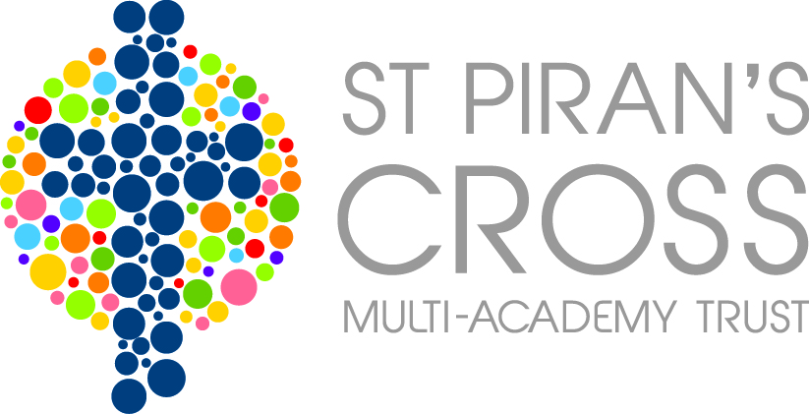
St Piran’s Cross C of E Multi-Academy Trust
Pupil Premium Report – Grampound Road
Report Period 1st September 2014- 31st August 2015
This funding was received after conversion to a Multi-Academy Trust during the grant period 2014/2015 and 2015/2016.
PPG provides funding for two policies:
• Raising the attainment of disadvantaged pupils and closing the gap with their peers; and
• Supporting children and young people with parents in the regular armed forces

The period of reporting spans over two different grant allocations. Please see information below.

Pupil Premium Grant (PPG) Received
1st September 2014- 31st August 2015
Funding carried forward from previous period |  | £0
Total amount of funding received in this period |  | £42527
Total amount of funding received |  | £42527
Nature of Support 1st December 2014- 31st August 2015 and allocation of PPG | Amount | Impact Statement
Booster - Teacher | £16029.50 | Through analysis of pupil progress, achievements, pupil conferencing and observations the additional teacher for boosting has made a positive difference. Level of confidence improved. Pupils were able to access quality pre-teaching or consolidating of learning through these sessions. Year 6 pupils and their achievements highlight the significance of this.
Stick at it lessons | £705.76 | Pupils have grown in confidence. They are able to concentrate for longer periods of time. Improved and better self-esteem meaning they are persevering in other areas of learning. Pupils prepared to play to an audience/parents at Christmas Play. Felt a sense of pride and achievement. This is now impacting other areas of academic achievements.
Mindset Training | £675 | Teachers and pupils understand the difference between growth and fixed mind-set. Parents found workshop inspiration and gave helpful tips and strategies to support pupils with learning at home in a positive way. One parent commented: My child now says ‘I can do’ instead of ‘I can’t do that’.  Art project: to build self –esteem and confidence.  14 pupils from pupil conferencing identified an improved confidence and self-belief in what they could achieve. Improved self-belief in own skills. Now say: “I can’t do that yet” demonstrating a growth mind-set.  This has supported the school changing completely behaviour and attitudes to learning. We are developing this further with work on independent learners and 4 before me.
TAs interventions | £22907.89 | Through analysis of pupil progress, achievements, pupil conferencing and observations the teaching assistant interventions for pupils have made a positive difference. Level of confidence improved. Pupils were able to access quality pre-teaching or consolidating of learning through these sessions. Children developed confidence and fluency with reading, spelling, understanding of reading and maths. Evidenced in year 6 results.
PSA | £2065.46 | Parents who have received support from the PSA have recognised how beneficial it has been to support their children in accessing education. Been really effective working with the SENDCO and preparing families for what they need. This has also been crucial for secondary transition as support has been in place via the PSA. Meaning pupils are more confident at transition.
Materials | £14.99 | The materials were used to support the teaching assistant interventions and growth mind-set. This meant the impact of this was extremely positive.
Transport | £128.40 | Children are now able to attend school regularly. It has improved their attendance and punctuality. This in term means pupils are learning and building up confidence with this.
Total Expenditure | £42527
Amount carried forward | £0

