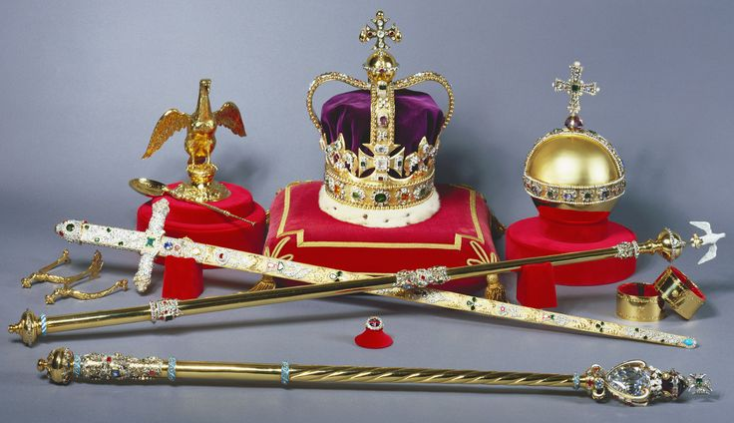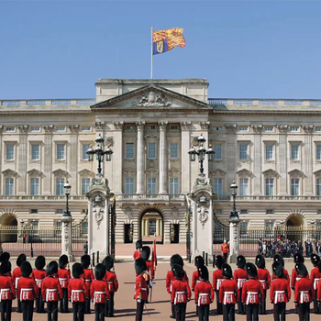

Staff:

Miss Eastham (Class Teacher)

Miss O’Shaughnessy (Teaching Assistant)

Mrs Warne (Teaching Assistant)

Mr Jarvis (Sports Leader)

Homework and Spellings:

This term we will be continuing to follow the RWI spelling scheme in school. In units 8-12, the scheme teaches children how to write suffixes, use the ‘igh’ sound spelt with a ‘y’ and write using silent letters. We will also be completing a common exception word spelling test to identify gaps in the children’s knowledge of common exceptions words. **Helping your child to learn their spellings will really make a difference!**

**Homework will still be set on a Friday and should be completed by the following Wednesday. Spelling tests will be given on a Thursday this term, so that they can be marked ready for Friday.** As always, thank you for your ongoing support. I hope you feel your child is settled, happy and making good progress.

Kings and Queens

**What does it mean to be a royal?**

**A little taste of what we’ll be doing…**

* **Hosting our own high tea party.**
* **Creating our own class family tree and researching the history of the royal family.**
* **Creating a timeline of the British Monarchy**
* **Hosting a medieval inspired banquet.**

Tater Du

Curriculum Newsletter

Spring 2018

History:

In History this half term, we will be learning about the history of the monarchy in Britain. We will be creating a timeline of the monarchy since 1066 and will be exploring different significant individuals and why they are important. As part of this, we will explore how this change has affected us. We will also be creating our own family tree as well as our own class family tree.

Geography:

In Geography we will be exploring human geography and will be understanding different types of settlement and land use in the United Kingdom. We will also be looking at changes over history linked to our topic of Kings and Queens.

ART:

In art this term we will be creating our own self-portraits in the Tudor style, and we will be designing appealing leaflets to advertise the products we make in DT.

D.T:

As part of our ‘real world outcome’, we will be designing and preparing a medieval inspired banquet. We will be exploring the differences between our diet today and the diet of Kings and Queens in the past and we will be using this knowledge to create our own medieval banquet.

Music:

In Music this half term, we will be listening to different types of music and composing our own music for others to listen to. We will be working in small groups to provide feedback on each other’s’ music, as well as performing to each other.

Primary Languages:

This half term, we will be learning some French. We will learn simple phrases and key words.

P.E.

P.E. this half term will take place on a Thursday morning (with Mr Jarvis teaching) and a Monday afternoon. Mr Jarvis will be teaching gymnastics, and on a Monday afternoon we will be learning different dance techniques before performing our own dance.

Please ensure your child has their P.E. kit in school on a Monday and a Thursday. Thank you.

Maths:

In Maths this half term, we will be revising our number bonds to 10 and 100 to support us in other areas of Maths. We will be learning about 2D and 3D shapes, and exploring symmetry in shapes and patterns. We will also be focussing on measurement, in particular money, and we will be applying this to different contexts. We will be having an ongoing focus on ‘mastery’, which includes using Maths in real life, real world situations. We will be practicing our times tables frequently this term, and homework will be linked to this, please practice with your child if you get the chance as this will support them in and out of school!

English:

In English, our first class story (Belle’s dilemma) introduces our topic. We will be exploring this story and the use of different language features to hook the reader. We will continue to develop our understanding of different texts during guided reading, and making predictions about what we think will happen next. When reading with your child, see what nouns, adverbs, adjectives and conjunctions they can identify in their books. This will support their writing in class. We will also be continuing to focus on our handwriting and joining letters, lots of us are very close to that pen license!

Science:

In Science we will be studying animals, including humans. We will look at what animals and humans need to survive, and nutrition. We will consider what nutrition and diet is, and what contributes to a healthy diet. We will also be looking at the difference between animals and humans and the importance of their muscles and skeletons.

Computing:

In computing, we will be focussing on computer skills on word. We will be using the internet to research the British monarchy and create a leaflet using different word processing skills.

Religious Education:

In R.E., we will be learning about Hinduism and what their main beliefs are, as well as exploring special festivals and the meaning of different symbols.

This list is a brief summary of what we will be covering in the Spring Term. It may change or include other areas. Please feel free to ask the class staff any questions you might have about the content of the curriculum or any other part of school life.